o

N O

o !

C«i -0 n

«g: o

O' rn

no *

OOJ

?-i

ns

*«->

* cu JeO

*go<

* .<±
* X < i xh- ^DZ #OCQ<
* W -J

#P3Q-«£

ay £1)02

Your Official  
2002 ALOA  
Official Proxy  
Voting Form

Inside!

0)



a

S&G Levers, Cannon Gun Safe  
and Servicing Techniques

The 2002 Chevy Trailblazer • Lock Pinning Techniques and Your Official 2002 ALOA Official Proxy Voting Form

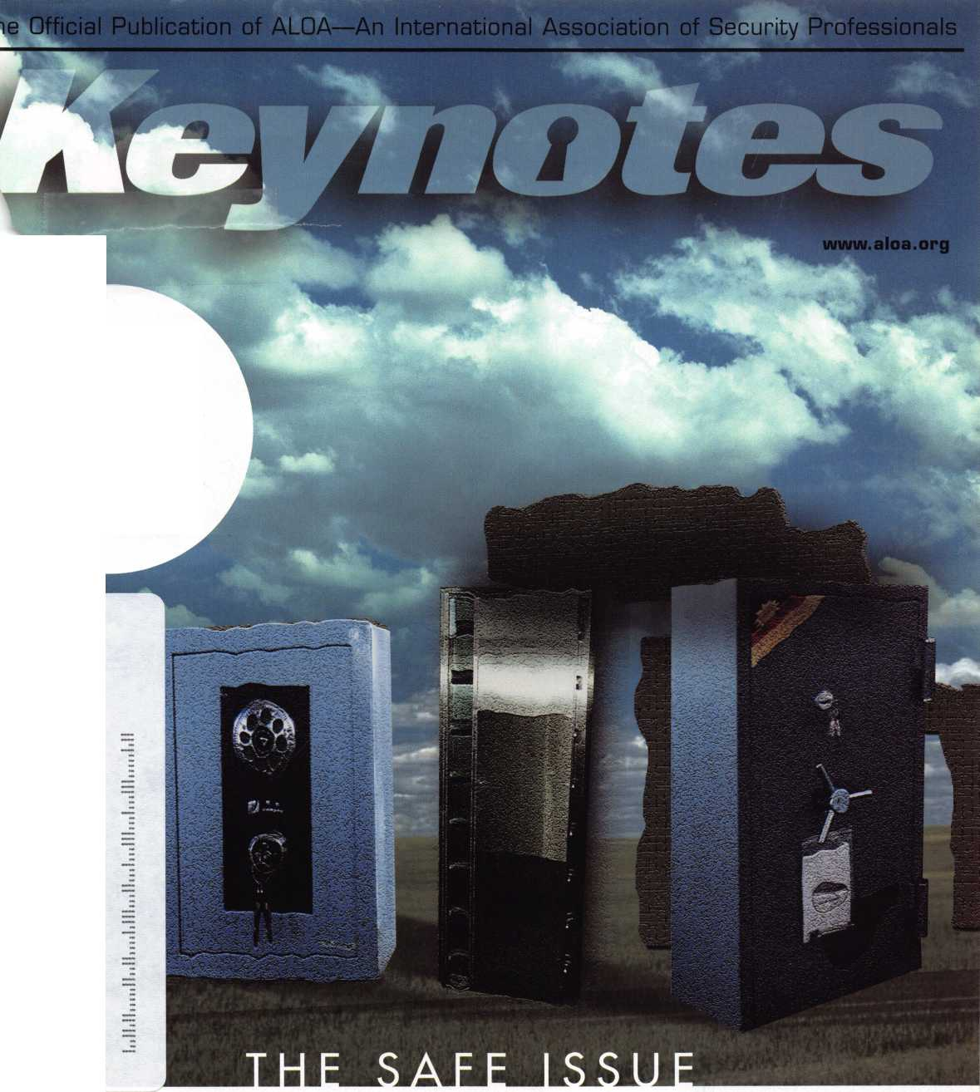

The Originals Stand Alone

**STRATTtC**

Leadi"9 the Industry Since,9ti

Jaap

W '*•

m

KEtifTS

i. *mis*

__ jiJi> skt

mSs ' is ■ .1

*fj,,- .*

vw^SBfPSp.

Only STRATTECcan supply the 2000 Taurus and Sable transponder keys, along with other original Ford, DaimlerChrysler, GM, and Mitsubishi models. Only STRATTEC is America's largest transponder key OE supplier. So only STRATTEC's keys hit the market the same time the new cars do. Alone among the competition, STRATTEC has the technological experience that comes with leadership. Nobody else offers the STRATTEC seminars that keep you up to date with the latest in security technology. Nobody else gives you that kind of support; the originals stand alone, so you don't have to.

599452 - Chrysler RFID Valet Key 89 Groove 690556 -

690222 - Chrysler RFID Primary Key 84 Groove 690554 -

690224 - Chrysler RFID Valet Key 85 Groove 598333 -

690226 - Chrysler RFID Key 90 Groove 599902 -

599450 - Dodge RFID Key 90 Groove 599179 -

599455 - Dodge RFID Key 84 Groove 599114-

690504 - jeep RFID Master Key 84 Groove 598992 -

690223 - Neon RFID Key 84 Groove S99A79 -

690SS2 - General Motors 75 Groove RFID Key

General Motors Primary 88 Groove RFID Key General Motors Valet 75 Groove RFID Key Ford Primary Molded 82 Groove PATS Key Ford Primary Molded Encrypted 82 Groove PATS Key Mercury Sable Primary Molded Encrypted 82 Groove PATS Key Ford Taurus Primary Molded Encrypted 82 Groove PATS Key Mitsubishi Primary Molded 90 Groove RFID Key Mitsubishi Valet 89 Groove RFID Key

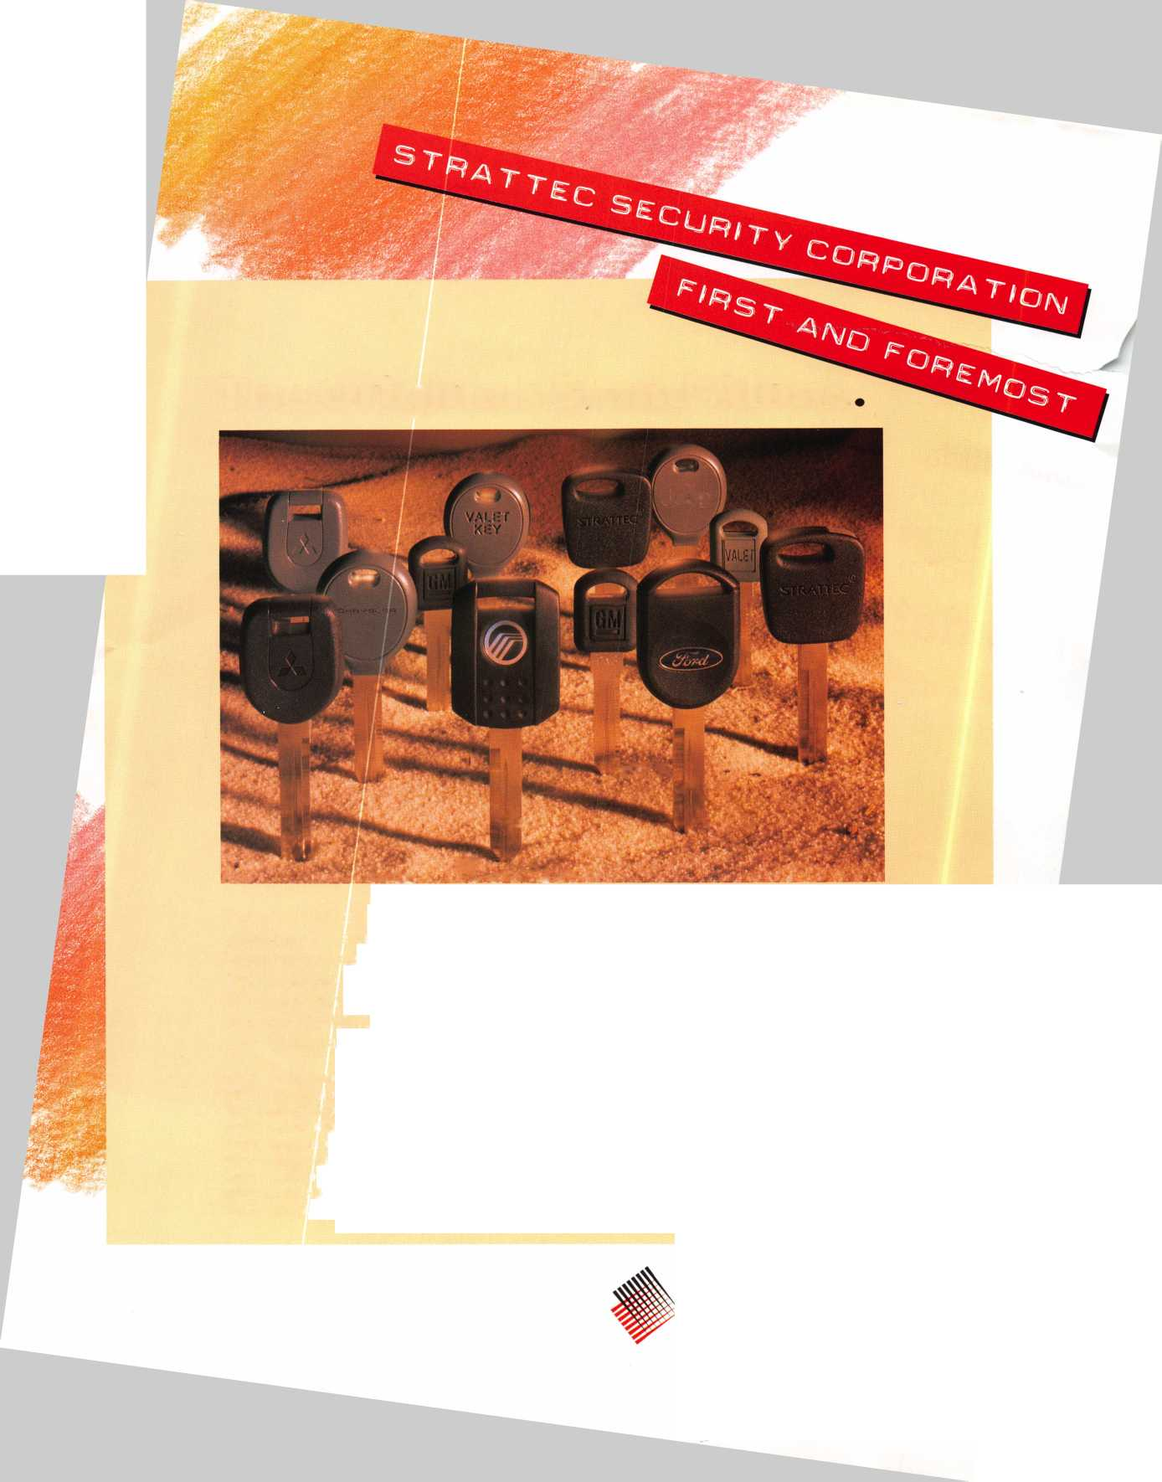

**Register IMow**

I

*Wm*

*mmB&m*

I®

ly 22-28, 2002 • Donald E. Stephens Convention Center • Hyatt Regency O'Hare For more information, call 800-532-2562 or visit our webste at [www.aloa.org](http://www.aloa.org).

ra



**f e a t u res**

COVER: The Safe Issue

r **1**

**departments**

Contents 2

Executive 3

Applicants 6

Calendar 8

Core 10

Legislative Update 38

Classifieds 40

Associate Members 42

Back Page 44

**L ^**

12

Safes: What a Difference

a Lever Makes *by* Brian costiey, *cml, cmst*

ALOA Award Recipient Brian Costly, CML, CMST, takes you on a trip through S&G's various lever designs, complete with historic significance of the lever design and other pearls of wisdom.

**17**

Cannon Gun Safe:

Membership Has Its Rewards by Greg Perry, cml, cps

LaGard had a local job for its Cannon gun safe and found our author through his memberships in ALOA and SAVTA. He didn't disappoint.

**20**

Safe Servicing Techniques:

The Major TL-30 Money Chest By Milton Wolferseder, RL

Get some valuable ins and outs about how to deal with this one- of-a-kind locking arrangement for Major's TL-30 rectangular money chest.

**22**

Automotive: Blazing Through the

Chevy Trailblazer By Jeff Trepanier, RL

Auto guru Jeff Trepanier, RL, takes you step-by-step through the servicing techniques used for the completely re-designed 2002 Chevrolet Trailblazer.



Basic Locksmithing:

Pinning Locks By Merritt Perkins, RL

This piece covers pinning techniques for common locks, and cov­ers material used for beginners.



2002 ALOA Elections

Find out all you need to know about our candidates before voting on the ALOA officers for the next year. Remember: Voting is your privilege as a member - take advantage of it!

Visit our website at [www.aloa.org](http://www.aloa.org)

ll^l Keynotes • May 2002

**executive**



Additional contact information for the ALOA Board and most Keynotes authors is available through "Locksmith Search'" on the ALOA Web site- [www.aloa.org](http://www.aloa.org) or by contacting the ALOA office at 3003 Live Oak Street; Dallas, TX 75204; (800)532-2562; FAX (214)827-1810; e-mail [aloa@aloa.org](mailto:aloa@aloa.org).

Editor

Jim DeSimone [editor@aloa.org](mailto:editor@aloa.org)

Operations/Membership Manager

Mary May [mary@aloa.org](mailto:mary@aloa.org)

Technical Editor Director of Information Technology

David Lowell, CML, CMST [david@aloa.org](mailto:david@aloa.org) Randy McChristian [randy@aloa.org](mailto:randy@aloa.org)

Editorial Advisor

John D. Cannon, CML [jdcannon@worldnet.att.net](mailto:jdcannon@worldnet.att.net)

Art Director

Betty Henderson [betty@aloa.org](mailto:betty@aloa.org)

Government Affairs Manager/

Chapters & Regional Associations Liaison

Tim McMullen [tim@aloa.org](mailto:tim@aloa.org)

Comptroller Kathy J. Romo

Network Specialist Greg Jackson

Membership Coordinator Shelly Jett

Convention & Meetings Assistant Karen Lyons

PRP/Education Coordinator Ashley Manson

Accounting Coordinator Kathy Green

Mail Room Coordinator Dennis Henderson

Advertising Sales

Kim Hammond

Executive Director

Charles W. Gibson, Jr., CAE

PRP/Education Manager

David Lowell, CML, CMST ..

Contributors

Jerome Andrews, CML Paul Chandler, CRL Claire Cohen, CML Brian Costley, CML, CMST Ray D'Adamo, CML

voice: 817-645-6779

Fax: 817-645-7599 e-mail: [adsales@aloa.org](mailto:adsales@aloa.org)

[charlie@aloa.org](mailto:charlie@aloa.org)

.[kelly@aloa.org](mailto:kelly@aloa.org)

[david@aloa.org](mailto:david@aloa.org)

Sal Dulcamaro, CML Billy Edwards, CML Dan Graffeo, CRL,CMST AJ. Hoffman, CML Jeff Nunberg, CML, CMST

Mike Oehlert, CPL, CPS Randy Simpson, CML Robert Stafford, CML Dave Thielen, CML Greg Perry, CML,CPS

Tom Seroogy Charles Stephenson, CPS Dennis Watanabe, CML, CMST

Convention & Meetings Manager

Kelly Carr, CMP

Mission Statement: The Associated Locksmiths of America, Inc. is dedicated to enhancing the professionalism, education and ethics among locksmiths and those in related sectors of the physical security industry. With approximately 10,000 members in the United States, Canada and the freeworld, ALOA is poised to help members obtain the knowledge, the strength, and the confidence to perform their role in the physical security field with pride and dignity. But it is only through active involvement and participation that ALOA can fully achieve its potential—and can help members to achieve theirs.

Policies: Keynotes® is the official publication of the Associated Locksmiths of America, Inc. (ALOA). Keynotes® acts as a moderator without approving, disapproving, or guaranteeing the validity or accuracy of any data, claim, or opinion appearing under a byline or obtained or quoted from an acknowl­edged source. The opinions expressed by the authors do not necessarily reflect the official views of ALOA. Also, appearance of advertisements and new products or service information does not constitute an endorsement of products or services featured by the Association. The Association does not accept responsibility for the inaccuracy of any data, claim, or opinion appearing in this publication, due to typographical errors on the part of the authors, Association staff or its agents.

Editor's Note: This publication is designed to provide accurate and authoritative information in regard to the subject matter covered. It is provided and disseminated with the understanding that the publisher is not engaged in rendering legal or other professional services. If legal advice and other expert assistance is required, the services of a competent professional should be sought.

Authors' Payment: Payment for eligible submissions to Keynotes will be based on the following criteria: topic, time spent and past contributions. Authors who regularly submit to Keynotes® are generally paid a higher rate. The latter is especially true of authors who write to fit specific editorial needs and submit said copy by Keynotes® deadlines. As a general guideline: Average payment for a 750 word, business or light' technical article would be $200. Payment for a 1500 word article involving significantly higher time and research efforts would be $400.

Payment will not be offered for articles submitted by ALOA employees or members of the ALOA Board of Directors (unless material is of a technical nature), nor for articles submitted by a company that promote that company's products or services. ALOA reserves the right not to pay for articles sub­mitted by an individual(s) that promote a particular company's products or services.

Disclaimer: The Associated Locksmiths of America, Inc., (ALOA), reserves the right to refuse any article for any reason. Additionally, ALOA reserves the right to edit, amend or modify any article submitted for publication in order to preserve technical accuracy, clarity, fairness or grammatical cor­rectness. ALOA will make the best efforts to notify the author of any changes. The extent of ALOA's liability for any article or information contained therein will be a notice of correction or retraction in the next possible issue.

Keynotes® (ISSN 0277 0792) is published monthly except for the combined June/July issue by The Associated Locksmiths of America, Inc., 3003 Live Oak St., Dallas, TX 75204-6186. Telephone: (214) 827-1701; FAX (214) 827-1810; e-mail [aloa@aloa.org](mailto:aloa@aloa.org). Subscription rates for members—$15.00 per year. Second class postage paid at Dallas, Texas. POSTMASTER: Send address changes to: Keynotes, 3003 Live Oak St., Dallas, TX 75204-6186. © Copyright 1999, All rights reserved. No part of the contents may be reproduced or reprinted in any form without prior written permission of the publisher.

President

Randy Simpson, CML  
(713) 780-7026  
[president@aloa.org](mailto:president@aloa.org)

Secretary

John D. Cannon, CML  
(703) 960-6413  
[secretary@aloa.org](mailto:secretary@aloa.org)

Directors, Northeast

John C. Magee, III  
(856) 845-3434  
nedirector@aloa .org

Peter Sarailian, CRL  
(973)8909797  
nea i rector@a loa. org

William L. Young, CML  
(610) 647-5042  
nedirector@aloa .org

Directors, Southeast

Vincent Formon, CML, CPS

(901) 324-2910  
sed i rector@aloa .org

Donald E. Rule, CML  
(662) 324-2658  
sed i recfor@a!oa. org

Directors, North Central

Mark E. Blum, CML, CPS  
(517)482-5809  
[ncdirector@aloa.org](mailto:ncdirector@aloa.org)

John Soderland, CML, CMST  
(414) 327-5625  
[ncdirector@dioa.org](mailto:ncdirector@dioa.org)

Director, South Central

Randy L. Simpson, CML

1. 7807026 [president@aloa.org](mailto:president@aloa.org)

Directors, Southwest

Gordon R. Racine, CML  
(719) 384-4707  
swd i rector@a loa. org

Julie McCluney, CRL

1. 636-5652 swd i rector@a loa. org

Director, Northwest

Scott L. Henke, CRL, CPS  
(907) 248-3785  
[nwdirector@aloa.org](mailto:nwdirector@aloa.org)

Director, Associate Members

David F. Matthies  
(727) 541-5536  
[asdirector@aloa.org](mailto:asdirector@aloa.org)

Trustees

[trustees@dloa.org](mailto:trustees@dloa.org)

John J. Greenan, CML, CPS  
(773) 486.2030

Dallas Brooks  
(334) 826-8990

David M. Lowell, CML, CMST  
(800) 532-2562

Edwin Toepfer, RL

Past Presidents

1999-2001 John Greenan, CML, CPS  
1997-1999 Dallas C. Brooks  
1995-1997 David Lowell, CML, CMST  
1993-1995 Breck Camp, CML  
1991-1993 Henry Printz, CML  
1989-1991 Evelyn Wersonick, CML, CPS  
1987-1989 Leonard Passarello, CPL  
1985-1987 Joe Jackman, CML  
1983-1985 Stanley Haney, CPL  
1981-1983 Louis LaGreco, CPL  
1979-1981 John Kerr, RL  
1977-1979 Clifford Cox, CML  
1974-1977 Charles Hetherington  
1972-1974 Gene Laughridge  
1970-1972 William Dutcher, RL  
1968-1970 Constant Maffey, RL  
1966-1968 Harold Edelstein, RL  
1964-1966 William Meacham  
1962-1964 Robert Rackliffe, CPL  
1960-1962 Edwin Toepfer, RL  
1956-1.960 Ernest Johannesen



Keynotes • May 2002

president

**journey**

**i**

s

Hello Members,

I hope today finds you and your family in good health and prosperity. Too often in our dai­ly lives, we dwell just on the small things in our pursuit of happiness. The argument that could've been avoided. Getting the runaround at the store. Being misunderstood and hav­ing someone act on bad information against you. And I think ALOA falls victim to these small hurts in too many cases. This organization exists for you, the members, and our asso­ciation - like our great profession - will always be only as good as the sum of its parts. ALOA performs a host of different services for its members, almost always at excellent lev­els. When we fall short of excellence in our performance, it's unfortunate, yes. But when we lose good, irreplaceable people, I say that we are more deeply wounded. When we lose those who want to help the profession grow, we are at our weakest. Jerome Andrews, a good friend of mine has a saying "It's not a bad day unless someone you know has died."

Today is a bad day. Our industry is mourning the loss of one our colleagues; more than a great leader, we've lost a great friend.

James Glazier Sr, CML, passed away on April 17, 2002, after a long, courageous battle with cancer. As a former ALOA board member and longtime ACE instructor, Jim gave of himself to the benefit of all who had the pleasure to know him. His contributions to our asso­ciation are evident in our educational and membership programs, which are vastly expand­ed and enhanced today because of Jim's tireless work. Our association has lost a great mentor, educator and friend. The organization is diminished exponentially more by this loss than by any other small hurt or damaging word against it. Members who rise to the chal­lenge of sharing knowledge and assistance with their fellow members are the very essence of what this organization wants to be, and what it still can be.

Who will replace Jim Glazier, now that he is no longer with us? Could it be you?

Randy Simpson, CML

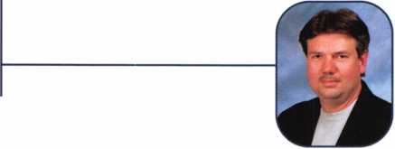

Keynotes • May 2002



***Visit our Website on****[www.stamcctv.com](http://www.stamcctv.com)*

**THE COMPLETE**

**CCTV PROGRAM ON CD-ROM  
FOR STAFF TRAINING AND**

**PRODUCTIVITY ENHANCEMENT**

STAM **Insight** has been  
developed to enhance CCTV

skills and productivity with  
many different uses.

**HI** Productivity

HI System Drawing HI Estimation **#** CCTV Training HI CCTV Reference HI Sales/Demo HI System Design HI Staff Evaluation

hours

Estimation

Drawing

Internet Enabled

Knowledge Assessment

**NFOMATE WORKMATE ULTIMATE**

CCTV Content

CCTV Calculators

Demonstration Tool

Sold in Over 50 Countries

Distributed by:

3003 Live Oak Street  
Dallas,Texas 75204



COPYRIGHT © 1996 Security Training and Marketing Pty Ltd.  
All rights reserved ACN 057 006 541

Country

Tel: ( )

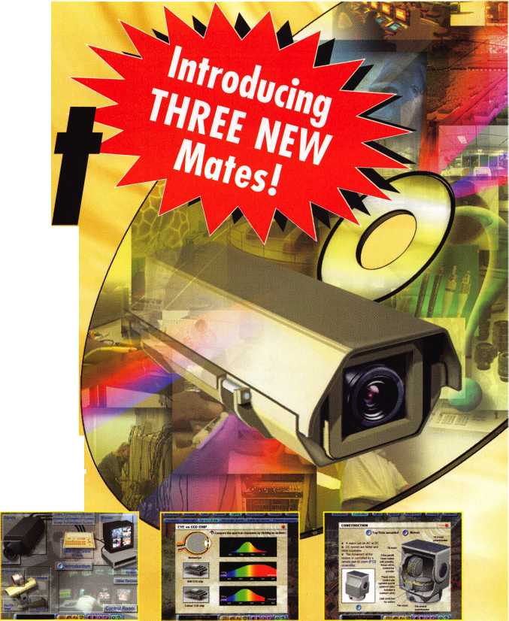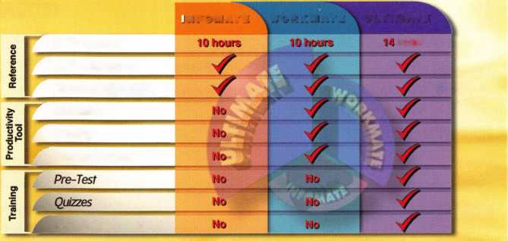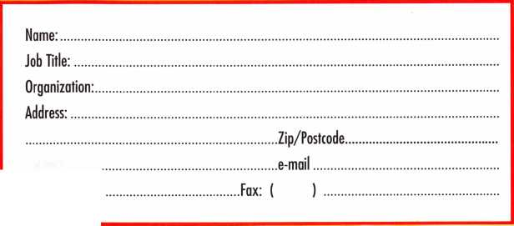

AZ

Orlando

MA

MN

Lakeside

Gary Renfro

Parker

David M. Shelton

Sponsor: William Lee

CA

Garden Grove

Tran M. Hung

Sponsor: Julie McCluney CRL

Hemet

Autley Musselwhite

Napa

Larry Thomason

Sponsor: Carl A. Fowler RL

Oakland

James G. Zigenis

Oceanside

Robin W. Varian

Sponsor: Gregory L. Perry CML, CPS

Palm Desert

Robert Airrington

Sponsor: Kelvin R. Meier CML

San Diego

Anthony J. Bosso

Sponsor: Gregory A. Parks CRL

*co*

Denver

Britta Singer

FL

Clearwater

Danny Gulley

Largo

Roger E. Jordan Sr, CRL

Sponsor: Vincent L Formon CML, CPS

Kenneth Potts

Sponsor: Jimmy D. Haveard

Wellington

Paul J. Vowles

Sponsor: Norbert King RL

GA

Marietta

Warren D. Discon

Sponsor: Robert D. DeWeese CML

HI

Honolulu

Somsavath Phommachanh

Sponsor: Herman Salz CPL

Pearl City

Gary M. Matsumoto

Sponsor: Joseph W. Whitaker CPL

IA

Clinton

Ryan Bradley

Sponsor: Robert Hartz

Davenport

Robert Peppers

Sponsor: Robin Peppers

Chicago

Ivan Colon

Kankakee

Jeremiah L. Ford

Sponsor: Michael G. Boisvert CML

LA

Kenner

Merlin R. Young

Sponsor: Robert D. DeWeese CML

Beverly

Jason Fournier

Sponsor: David M. Troiano

Chelsea

Ramon E. Perez

Sponsor: David M. Troiano

Dorchester

Christopher Deane

Sponsor: David M. Troiano

Fitchburg

Jeffery T. Ide

Jamaica Plain

Michael A. Troiano

Sponsor: David M. Troiano

Medway

Jason Siegel

Sponsor: David M. Troiano

Roxbury

Richard K. Burns

Sponsor: David M. Troiano

MD

Abingdon

Luke A. Hofmann

Sponsor: Christopher R. Brennan

Baltimore

Simone L. Brown

Laurel

Jeffrey Gowombeck

Sponsor: Michael B. Groves

Manchester

Michael Clayton

Sponsor: Michael B. Groves

Ml

Flint

Gary F. Kortas Sr

Sponsor: Frances C. Katz

Minneapolis

Olaf Schistad

Sponsor: Sandy Sproat

Saint Paul

David Bristol

Sponsor: Michael P. Mattern CRL

MO

Saint Louis

Nicholas Naimo

MT

Bozeman

Edward S. Fluke

Great Falls

Kent Williamson

Sponsor: Dale L Nelson CML

NC

Candler

Brian McFee

Sponsor: Robert D. DeWeese CML

NJ

Bloomfield

Kelly Garrett

Sponsor: Eric E. Williams

Carteret

Peter Chubenko

Moorestown

Michael R. Fischbach

North Bergen

Steven A. Vanegas

Sponsor: Walter W. Lascar RL

NV

Las Vegas

Juan M. Matamoros

Sponsor: Ernest W. Wright

These applicants are scheduled for clearance as members of ALOA. The names are published for member review and comment within 30  
days of this Keynotes issue date, respectively, to ensure applicants meet standards of ALOA's Code of Ethics. Protests, if any, should be  
addressed to the Membership Department and must be signed. Active Membership applicants (a) have worked in the industry two or more  
years. Allied Membership (AL) applicants are not locksmiths, but work in a security-related field. Apprentice Membership (AP) applicants

have worked in the industry less than two years.

6

Keynotes • May 2002

NY

TN

ilmira

Hank Fuller

Sponsor: Mark W. Fuller CRL

Eric Costley CRL

Sponsor: Mark W. Fuller CRL

lye

Billy Matthews

fa I ley Stream

Ralph Costabile

OH

Aansfield

Frederic W. Ackerman

Sponsor: Thomas K. Gatfon

OR

Beaverton

Art La Perriere

Sponsor: William Blanchard CRL

fartland

Kenneth Blanchard

Sponsor: William Blanchard CRL

PA

•phrata

James Duty Jr

Sponsor: Tedd W. Madara

Aarienville

Craig McClintock

Sponsor: James M. Hunter

SC

slorth Myrtle Beach

Peter N. Spirakis

tedmont

William R. Jones

Sponsor: Mark M. Mullinax

Ramer

Philip A. Hollingsworth

Sponsor: Gary S. Mooney

TX

Abilene

Timmy L. Savage Gary McDonald

Sponsor: James V. Hawley CRL

Austin

Roy E. Van Zandt Sr

Sponsor: Steve L. Cothron

VA

Manassas

Christopher Nilson

WA

Lynnwood

C Leon Richardson

Sponsor: Herbert C. Dusenberry CML, CPS

Tacoma

Paul J. Michel CRL

Wl

Madison

Curtis M. LaHaise

Sponsor: John W. Soderland CML, CMST

Sponsor: Gregory R. Weide CML

ia

Sofia

Dimitar Petrov

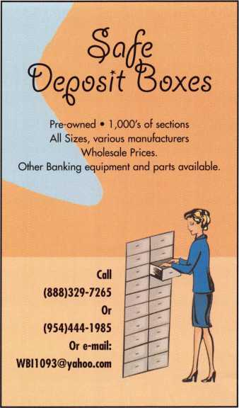

Canada

I Japan

BC

Abbotsford

Gordon Parr



Kowloon

Kin-Wah Yip

Sponsor: Kwok-kei Leung

Hiroshima-city Hiro

Satoshi Tanaka

Sponsor: Takashi Kuwana CRL

Ichinomiya Aichi Uno Masatoshi

Tokyo

Takeshi Tsuchida

Sponsor: Toshihiro Asano

Nanba Hiroaki

Sponsor: Toshihiro Asano



SAFE CORPORATION

MANUFACTURES OF QUALITY DEPOSITORY SAFES AND CHESTS

DISTRIBUTING FROM WAREHOUSES IN

* LOS ANCLES, CA
* CHICAGO, IL
* GLASSBORO, NJ

|  |  |  |
| --- | --- | --- |
| A & B is now a stocking distributor | | |
| for Mutual Safes |  | I— |
| featuring | !l | h*j  E*J. |
| AB-43035 AB-9FL WS 10-2 | | |

Chose from over 75 models in stock

We ship your order within

24 hours

See us

*at [www.a-bsafecorp.com](http://www.a-bsafecorp.com)*800-253-1267  
Fax 856-863-1208

CALL FOR YOUR  
CATALOG TODAY

Keynotes • May 2002

**OCT I SEPT I AUGUST I JULY I JUNE I MAY**

**upcoming**

|  |  |
| --- | --- |
| 1 Minnesota Chapter of ALOA  Membership Meeting [www.locksmithnews.com](http://www.locksmithnews.com) | 10 PRP • Dallas, TX 15 Central Florida Locksmith Associ- 16  (800) 532-ALOA (2562) ation Membership Meeting  [education@aloa.org](mailto:education@aloa.org) (386) 775-3641 |
|  |  |

Florida West Coast Locksmith Association (FWCLA) General Meeting (727) 849-1812

|  |  |
| --- | --- |
| 1-2 Greater Houston Locksmith Ass Intermediate Locksmithing with CD Lipscomb, CML, CPS  979) 323-9919 or <http://ghla>. 1 cis.com/index.htn | 2 Greater Houston Locksmith Assn. 2 North Jersey Master Locksmiths 14 PRP • Dallas, TX  Swap Meet Association 8th Annual Flea Mkt. (800) 532-ALOA (2562)  Contact: (979) 323-9919 or 201 /944-7547 or  <http://ghla>. 1 cis.com/index.html 973/777-0620  11 |
| 20 Florida West Coast Locksmith Association (FWCLA)  General Meeting (727) 849-1812 | 21 Central & Southern 21 Mount Diablo Chapter of 22-23 Greater Houston Locksmiths'  Colorado Locksmith Assn CLA Meeting Assn. Safe Penetration Party  (303) 688-4104 (707) 642-2661 w/Dave McOmie  (979) 323-9919 or <http://ghla>. 1 cis.com/index.html |
| : j | |
| 13-14 DHI Convention and Expo, Chicago, Illinois [www.dhi.org](http://www.dhi.org) | 1 8 Florida West Coast Locksmith 19 Central & Southern Colorado 22-28 ALOA 2002  Association (FWCLA) Locksmith Assn (800) 532-2562  General Meeting (303)688-4104 [www.aloa.org](http://www.aloa.org)  (727) 849-1812 |
|  | |
| 14-16 ISC EXPO/East 16 Central & Southern Colorado  Orlando, Florida Locksmith Assn  siaonline.org (303)688-4104 | |

14 Greater Houston Locksmith Assn. • Auto Opening with S Young • (979) 323-9919 or [ditels@fbtc.net](mailto:ditels@fbtc.net) <http://ghla>. 1 cis.com/index.htm

19

Florida West Coast Locksmith Association (FWCLA)

General Meeting (727) 849-1812

25-29 SERLAC Trade Show Orlando, FL (800) 845-529 [www.serlac.com](http://www.serlac.com) ACE

1-5 Pacific Locksmith Association Annual Convention Portland, OR 541/741-6902 [www.pla-pro.org](http://www.pla-pro.org)

27-29 Jo-Van Distributors Inc.

2002 Annual Security Show and Educational Conference 416/752-2238 or 888/752-7210



HS:



**events**

17 Central & Southern Colorado Locksmith Assn (303) 688-4104

1 8-19 Greater Houston Locksmith Assn. • Basic Locksmithing with CD Lipscomb, CML, CPS (979) 323-9919 or <http://ghla>. 1 cis.com/index.html

18 Mount Diablo Chapter of CLA Meeting (707) 642-2661

19 Central Florida Locksmith Associ­ation Membership Meeting (386) 775-3641

23 PRP* Socorro, NM

New Mexico locksmiths Assoc. 505/266-5577

23 Florida West Coast Locksmith Assoc. • Lockmasters Electronic Safe Lock Servicing with Brian Lamb • Tampa, FL (727) 849-1812

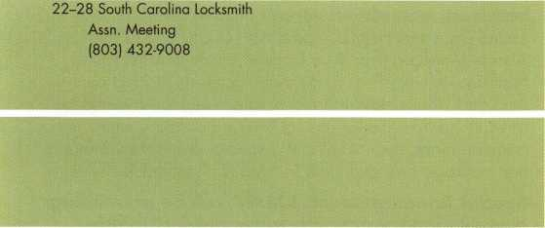

UPCOMING PRP SITTINGS

May 10 ALOA • Dallas, TX • Ashley Manson: 800/532-2562, ext. 30

June 14 ALOA • Dallas, TX • Ashley Manson: 800/532-2562, ext. 30

June 16 Clark Security Products • Reno, NV * Joan Emrick: 619/718-7308

June 23 New Mexico Tech Socorro • Socorro, NM • Brian Sweeney: 505/266-5577

June 14 ALOA • Dallas, TX • Ashley Manson: 800/532-2562, ext. 30

July 12 ALOA • Dallas, TX • Ashley Manson: 800/532-2562, ext. 30

July 26 ALOA • Rosemont, IL* Ashley Manson: 800/532-2562, ext. 30

Aug. 9 ALOA • Dallas, TX • Ashley Manson: 800/532-2562, ext. 30

Aug. 18 Clark Security Products • Elicott, MD • Joan Emrick: 619/718-7308

Sept. 13 ALOA • Dallas, TX • Ashley Manson: 800/532-2562, ext. 30

Sept. 22 Clark Security Products • Anaheim, CA • Joan Emrick: 619/718-7308

Oct.l 1 ALOA • Dallas, TX • Ashley Manson: 800/532-2562, ext. 30

Nov. 8 ALOA • Dallas, TX • Ashley Manson: 800/532-2562, ext. 30

Nov. 11 Crand Canyon Chapter of ALOA • Phoenix, AZ John Ilk, CRL, CPS: 602-420-2174

Dec. 13 ALOA • Dallas, TX • Ashley Manson: 800/532-2562, ext. 30

UPCOMING ACE CLASSES

June 29-30 July 21-28 Aug. 23-25 Sept. 11-13 Sept. 21-22 Sept. 25-27 Oct. 14-19

Northern Indiana Chapter of ALOA • Fort Wayne, IN Jermey Rodocker, CPL, CPS: 219/459-1500

ALOA 2002 Convention • Rosemont, IL • Ashley Manson: 800/532-2562, ext. 30

Central NY Locksmith Association • Syracuse, NY Ronald Smith, CRL: 315/658-2368

Nutmeg Chapter of ALOA • Nutmeg, CT Dale Hobbs, CRL: 203/237-4602

Central NY Locksmith Association • Ronald Smith, CRL: 315/658-2368

SERLAC • Orlando, FL • Michael Belden, CRL, CPS: 904/396-2022

Fox Valley Technical College • Appleton, Wl • Jerry Antoon: 920/735-2406 • [www.fvtc.edu](http://www.fvtc.edu)

In Memory

On April 17, 2002, longtime ALOA Instructor and former Board Member Jim Glazier, CML, passed on after a long, courageous battle with cancer at the Carroll County Cancer Center. In lieu of flowers, memorial contributions can be made to the Carroll County Cancer Center, 555 S. Center Street, Westminister, MD, 21 157.

After 20 years, Jim retired in 1978 as a lieutenant from the Montgomery Country Police Department, a career that allowed Jim to also serve as the Director of the Vice Intelligence Division. He was a former Baptist minister and was active in the Izaak Walton League of America for a number of years, as well as President of the Mt. Airy Lions Club. He was Security Director of InterAid International for 15 years and owner of Security Plus Locksmith for 16 years. He was a leader, an educator, author and recipient of numerous awards in the locksmith industry. On behalf of everyone at ALOA, we extend our sincere sympathies to Jim's wife Shirley; to his children Buddy, David, Michael and Alan; in-laws Lori and Betty; to his grandchildren Danny, Justin, Nikki and Owen, and to Justin Mossburg.

ALOA Convention Update

The banquet date is listed incorrectly on the convention brochure schedule (page 8). Please make a note of the correct date: Satuday, July 27, 2002 • 7-11 p.m.

Classes 322 and 408 in the convention brochure lists the course descriptions incorrectly. The correct descriptions fol­low. If you have any questions about our upcoming show in Rosemont, IL, this summer, call us at 800/532-2562.

322: AMSEC SafeWizard Access Control Seminar,

2 hour Evening Seminar, 7-9 p.m., July, 24th. Instructor: Tony Maniaci

American Security Products Company (AMSEC) invites all interested professionals to a casual evening seminar for the debut of the newest in Safe Access Control: The SafeWizard. Based on a powerful 32 bit processor platform, this Access Control System truly leapfrogs all systems currently available. Designed to provide information-age connectivity and fea­tures that far surpass any before it, the SafeWizard is the final answer to the reliability, support and operating com­plexities you have suffered with to date. Join us to see the SafeWizard, get a briefing on it's capabilities and have your questions answered.

408: AMSEC Certification Course,

8 hour-full day class, 8am-5pm, July 25th.

Instructor: Tony Maniaci

American Security Products Company (AMSEC) invites you to become a certified technician with the fastest growing safe manufacturer in the USA. Enjoy an intense and unique techni­cal look inside AMSEC, presented by Tony Maniaci, Director of Engineering and Manufacturing. This new class will fea­ture our ESL10 and ESL20 Electronic Safe Locks. Class will also cover:

Discussions on lock technology, both mechanical and elec­tronic; Safe drill points and opening techniques for all current production product lines; Hardplate technology and drilling techniques, tool requirements and tricks of the trade; Star Round Door service and repair; KPL100, KPL2000 and Access Manager overview; Electronic safe lock evolution, features and uses from many manufacturers; Product aware­ness and what's new and old in safe designs; An inside look at UL standards and ratings for fire and burglary safes. In addition, each student will get a special proprietary informa­tion package only available to AMSEC Certified Technicians.

Special Announcement: AMSEC will be premiering a revolutionary new electronic product in this class.

ATTENTION ALL ALOA MEMBERS!

This month is "sweeps" month for all the television networks. One thing they enjoy doing at this time of the year are their news team's "Investigative Reports". Many times this includes a "sting operation" where they will call a locksmith for a lockout to catch them not asking for identification. DON'T BE FOOLED!!! If you get called this month for a lockout, make sure you follow ALOA's Positive ID Policy - everyone will have their 15 minutes of fame sometime, but you probably don't want your's this way!

2002 SAFETECH By the Numbers

* Over $17,000 in fundraising (Friends of SAVTA Auction)
* Almost 500 participants
* Over 200 hours of classes

Keynotes • May 2002

ALOA's Positive ID Policy:

* ALOA locksmiths are instructed to use the following positive identification policy when servicing lockouts:
* Notify Caller. When a call comes in to request lockout serv­ices, ask the caller if he/she has identification and authority to open the lock.
* Complete Form. Upon arrival at the job site, the locksmith should complete an Authorization Form that asks for the name, address, phone number, identification number and property description from the customer.
* Verify I.D. Verify the customer's photo-identification card and compare it to the information provided by the cus­tomer. If no photo-ID card is available, ask for some other reasonable form of ID.
* Verify Authority. The locksmith should inquire as to what authority the customer has to open the lock, and request to see any reasonable and appropriate evidence that could verify the authority. This may be impossible in some cases/
* Ask for Signature. Ask the customer to sign the Authorization Form, which should contain a statement that (a) the information given by the customer is correct, (b) the customer has the authority to open the lock, and (c) the cus­tomer shall identify and hold harmless the locksmith against liability.
* Optional Last Resort. If you have any suspicions that the customer is giving false information or does not have authority to open the lock, say that you will be happy to open the lock provided a law enforcement officer

is present. If the customer agrees, call the police; if not, leave.

File the Form. Keep the Authorization Form on file for a

reasonable period of time.

Airport and Border Security

This week, while the U.S. Senate has moved forward with plans to fast track legislation addressing the growing concern with security at our nation's ports of entry, the U.S. House has begun to question the feasibility of its own plan to have all airport lug­gage screened by bomb-detection machine's by year's end.

Security experts are available to comment on all aspects of the homeland security issues currently facing our lawmakers. More information is available through Ancore, a developer of non- intrusive inspection systems who was recently awarded $10 mil­lion in federal funding to field test its scanning technology for use at U.S. border crossings. You can find them on the web at [www.ancore.com](http://www.ancore.com).

New Certifications

CML

Michael Yarberry

CRL

Stephen Gray  
Ben Heath  
Mark Lawson  
Jacob Matteson  
Michael McGuire  
William White  
Adam Wiewiora

Sellersburg, IN

Macomb, IL Warren, Ml Murphysboro, IL Beloit, Wl Westchester, IL Butte, MT Palos Hills, IL

Need Help?

At ALOA, we want to make sure you are getting as much bang for your membership dues buck as we are able to give you. If you have had problems getting membership services, or have a question regarding member services, please contact Bill Gibson, exectuve director, at 800/532-2562, or e-mail: [charlie@aloa.org](mailto:charlie@aloa.org).

Let Us Know!

If you have an opinion to offer on ALOA, the state of the indus­try, or life in general, we want to know about it! Submissions to the "Mailbox" section of Keynotes are printed on a space-avail­able basis. Write to: "Letters to the Editor"; ALOA; 3003 Live Oak Street; Dallas, TX, 75240; FAX 214/827-1810; e-mail: [editor@aloa.org](mailto:editor@aloa.org).

**11**

Keynotes • May 2002

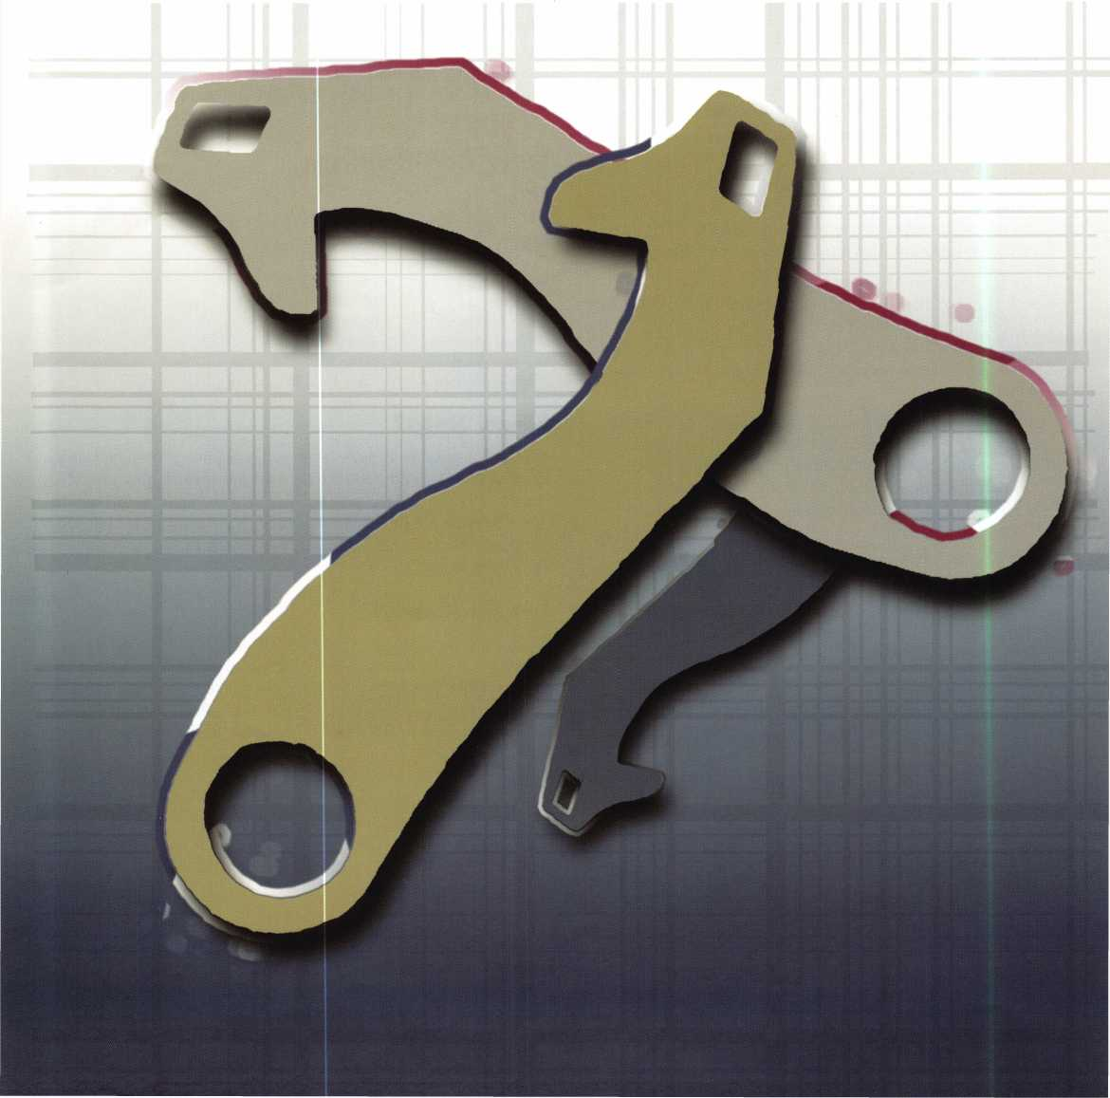

What a Difference

a Lever Makes.

by Brian Costley, CML, CMST

The drop lever combination lock has been in continuous use for about 150 years. Other designs (such as the roller fence lock) have appeared, disappeared, and reappeared, but you would be hard pressed to pinpoint an era in the history of combination safe locks when there was no production of a drop lever design.

Levers are usually among the first and most obvious components to undergo changes when a new or modified lock function is desired. The lever is so integral to a lock’s function that you can almost always tell a lot about the lock and its unique characteristics just by examining the lever. Skeptical? Let’s take a closer look at the lever...or should we say, levers.

This is a standard S&G three-wheel brass lever just prior to birth. All components are brass, but each is formed in a different way. The lever body

is stamped  
from sheet  
brass. The  
lever bushing  
(bottom of  
the photo) is  
machined  
from an  
extruded  
brass

rod, and the fence (topmost piece) is a simple brass extrusion.

These parts are assembled and soldered together to form the most recognizable combination lock lever in the industry. The fence geometry, com­bined with the geometry of the wheel gates, provides a maximum theoretical dialing toler­ance of nine tenths of a dial number.

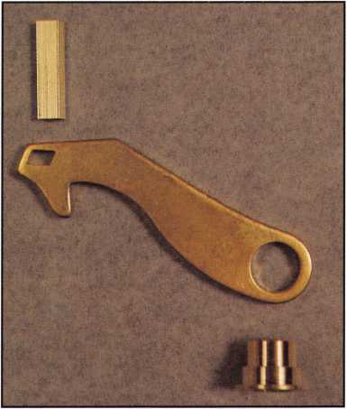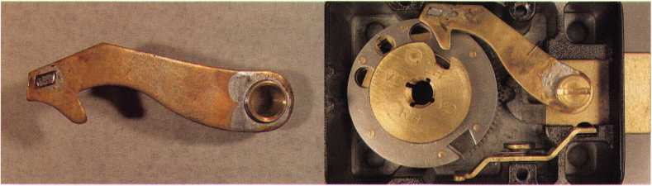

Keynotes • May 2002

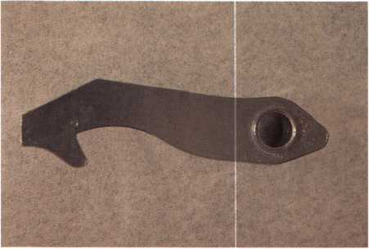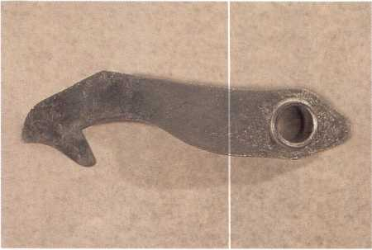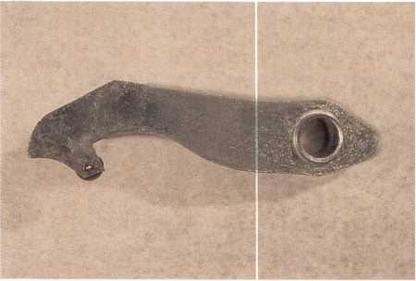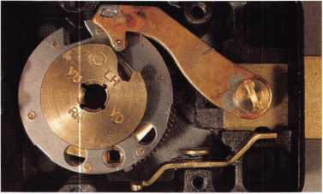

In practical terms, this seldom exceeds half a number. The combination of component tolerances inherent in a typical lock that would use this lever serves to narrow the dialing tolerance. When you service a lock that uses this lever, you should check a newly set combination by dialing a half number higher and half number lower than the set combination numbers. This ensures that your customer’s margin for error when dialing his combination will be evenly divided above and below the true numbers.

The flat end of the lever (left side) offers evidence that this design provides great resistance to bolt end pressure. The flat will tend to bind tightly against the lock case’s lever stop if force is applied to the end of the bolt.

On the other hand, inadvertent bolt end pressure of sufficient force can prevent the lever from dropping when the correct com­bination is dialed. This often happens when a piece of paper or cloth is caught between the safe door and the frame, and the door bolts are prevented from moving freely because they can’t line up properly with their corresponding holes in the frame.

See? A little knowledge of the lever can lead to valuable servicing and troubleshoot­ing information.

Here’s a variation on the standard three wheel lever. It’s die cast of Zamak 3, a com­pound that’s mostly zinc, with a small amount of aluminum. The profile is very similar to the standard brass lever, and it performs in much the same way. What you can’t tell at a glance is that it provides for greater dialing tolerances than its brass counterpart. When you set a combination into a lock that uses this lever, you should check your work by dialing a full number



Keynotes • May 2002

higher and lower than the set combination numbers. While this amount is still within the Underwriters Laboratories Standard 768 specifications for three-wheel lock dial­ing tolerances (plus and minus 1.25 num­ber), it allows the end user a greater margin of error than the brass lever.

The next lever is very similar to the last, but note the slightly rounded “head” at the left end. This identifies it as a push/pull lever. The lever tends not to bind against the lever stop when end pressure is applied to the lock bolt. This would be the lever of choice in a lock that has something attached to the end of the lock bolt.

The push/pull lever provides the same plus and minus one number dialing tolerance as its Zamak brother. Why are they both die cast? Simply because die casting is less expensive than machining and assembling brass levers.

Here’s yet another variation. The rounded head indicates that it’s a push/pull lever, and there is an eccentric roller in the nose. The lever nose is what rides on the edge of the lock’s drive cam whenever the dial is turned. The eccentric roller imparts a slight up and down motion to the lever as the drive cam rotates underneath it. This vari­able and unpredictable change in the lever’s position works to create artificial variations in the lock’s contact points, which skilled manipulators use to determine the combi­nation.

Therefore, a logical conclusion is that this lever design is used in a lock that needs some degree of resistance to expert manip­ulation. How right you are. The Zamak push/pull, roller nose lever is found in the S&G model 6651 Group 2M safe lock.

The Group 2M category was created by Underwriters Laboratories a few years ago

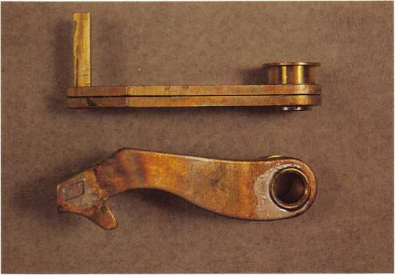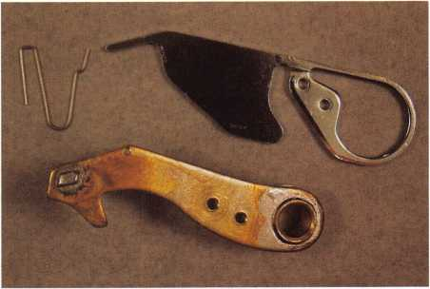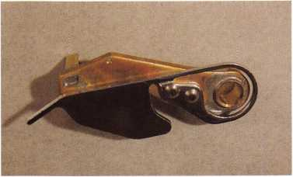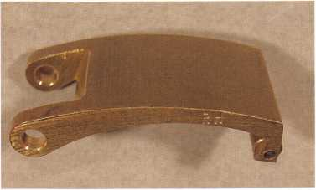

Keynotes • May 2002

to provide a higher level of lock security on TL-15 and TL-30. Listed safes, as well as some ATMs. The lock must provide a minimum of two hours of resistance to expert manipulation.

Although the roller in the lever nose goes a long way toward providing the required manipulation resist­ance, today’s manipulators are darned good, and S&G’s 2M locks also incorporate shallow false gates in the wheels. The false gates are visible in the lock pic­tured here. But wait! This is a brass lever with a roller nose. It’s a model 6630, and you’ve probably already guessed that it’s a Group 2M-listed lock. From what we’ve already learned about the brass style levers, you may have predicted that the dialing tolerance is the tight plus and minus one-half number. Right again. You’re getting good at this.

In case you’re wondering what the upside of tighter dialing tolerances is, the answer is more useable com­binations. Without going into the niggling details, suffice it to say that a lock with a dialing tolerance of less than one full number either side of the set num­ber offers almost three times the number of secure, non-overlapping, useable combinations than does a lock with a dialing tolerance of plus and minus one or more. The downside, of course, is that the lock must be dialed more carefully and precisely to successfully enter the combination.

The flat surface of the lever’s head also indicates that it provides strong resistance to forcing of the bolt. Note how the angled surfaces of the lever head and lock case’s lever stop match each other. As mentioned earlier, the downside to this is the fact that bolt end pressure tends to bind the lever head against the case stop, preventing the lever from falling when the cor­rect combination is dialed.

What’s going on with this lever? The body thickness is almost double that of a standard lever. That’s because it interfaces with a drive cam that is much thicker and more complex than that found in other locks. The 8400 series combination lock’s cam is composed of two sliding plates and a base assembly.

1

Without a thicker nose, the lever would not interact correctly with this cam, and the lock would lose its manipulation resistance. The 8400 series is UL-listed Group 1 and Group iR, which carries a 20 man-hour manipulation rating.

The strange collection of components shown here consists of a standard three-wheel brass lever with some extra holes, a large stainless steel accelerator spring, and a very small over-center spring, which is sometimes referred to as a “Z” spring (a look at the shape will tell you why). This is the only lever I can think of that has two lever springs.

The 8500 series lock is home to this strange lever.

It is a Group 1 or iR-listed combination lock with the requisite resistance to 20 man-hours of manipulation. The delicate balance between the tensions of the two springs controls the position of the lever during the dialing process.

As unusual and sophisticated as the 8500 series lever assembly is, it’s interesting to note that it’s all built on a platform that is nothing more than the standard three-wheel brass lever. The extra components were added to modify the operation of a regular drop lever lock. In fact, there is surprisingly little difference in the basic shape of all the levers we’ve looked at so far. It’s those minor differences, however, that make the completed lock assemblies behave in different and useful ways.

I couldn’t let this cursory overview of combination lock levers conclude without showing you the grandaddy lever of our time. This is a vault lock lever. At last we have a markedly different shape to observe. Even so, there is something familiar here. There is a roller in the lever nose (lower right end). Could this mean...? Yes, the vault lock destined to receive this lever is a manipulation resistant design. That eccen­tric roller rides on the lock’s massive drive cam, imparting an irregular up and down motion to the lever as the lock is dialed. Like Yogi says, “It’s deja vu all over again.” Q

**6**

Keynotes • May 2002

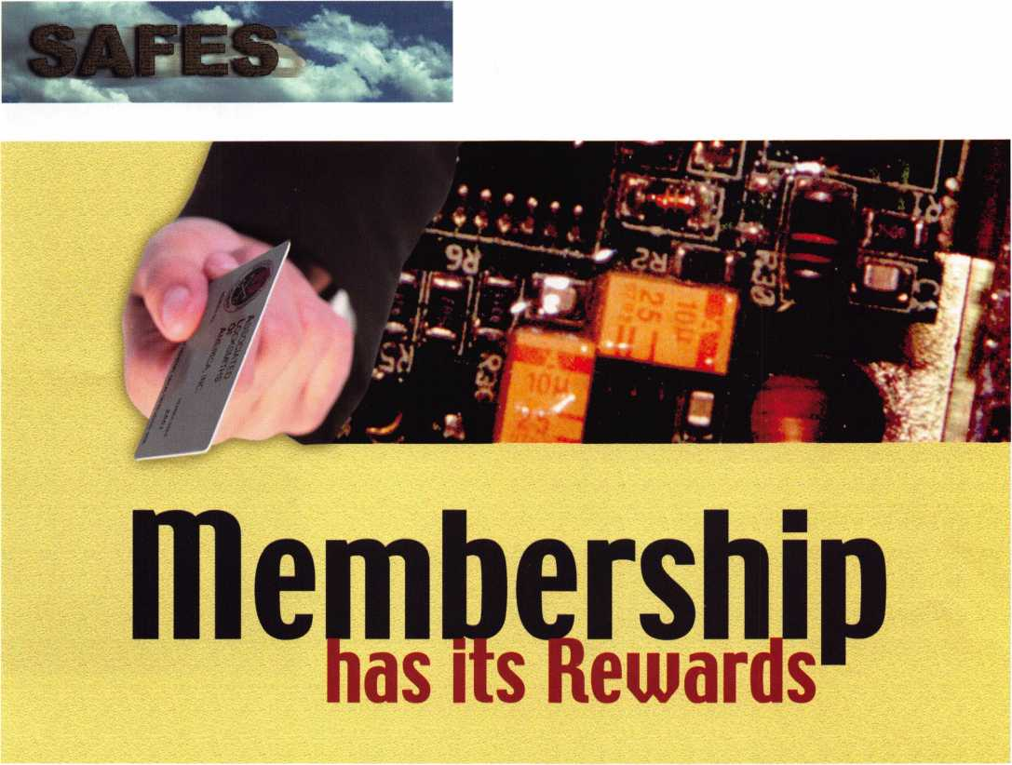

Manufacturers Give Business to ALOA and SAVTA Members!

By Greg Perry, CML, CPS

LaGard called recently asking if I could replace a keypad on a Cannon Gun safe at a local gun shop.

It seems the gun shop received a new safe with a malfunctioning LG Basic. Simply replacing the battery did not correct the problem. LaGard found us through my membership in ALOA and SAVTA. They felt replacing the keypad would solve the prob­lem. I was hoping it wouldn’t. They would overnight

a complete lock to me, and I set up a time with the gun shop to repair the safe.

Once in front of the safe, I tested the battery the customer installed. After only two days, it was dead. I replaced it with no response from the keypad.

The next step was to gently lift a corner of the keypad membrane. This would allow access to the mounting screws. Once they were removed, the key-

Keynotes • May 2002

pad was turned over and the cable from inside the safe was disconnected. I installed the new keypad. Again, the keypad did not respond. Time to drill, but where? I spoke with a factory technician, who recommended drilling for the solenoid. I wanted to try a different way.

Using a method explained to me by Michael Yarberry, I decide to spike the lock. The idea is to enter the lock case through the spindle or cable hole and apply power to the solenoid. Mike has developed a number of different spiking techniques as well as a tool for spiking many different electronic locks. Sounds easy enough, but it’s difficult to execute the first time. I drilled into the lock case with a cordless drill that had a weak battery. This allowed me to con­trol the entry and prevent the drill from damaging

The keypad membrane is lifted, exposing the  
mounting screws.



Keynotes • May 2002

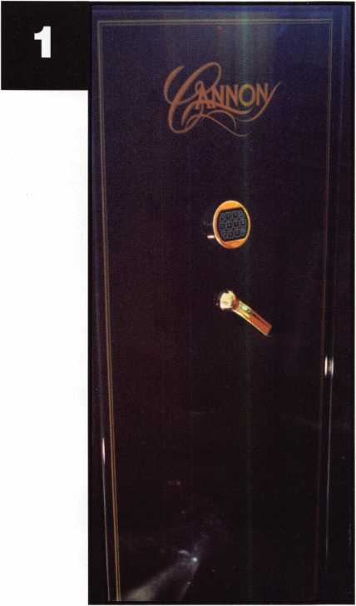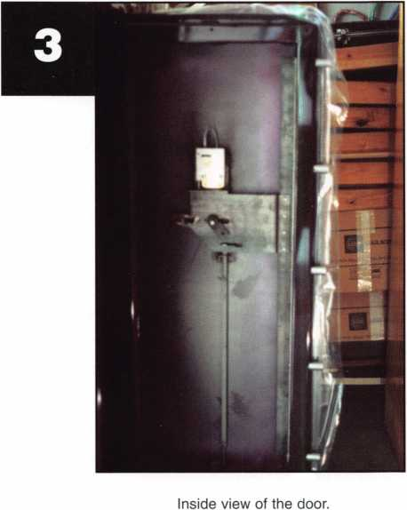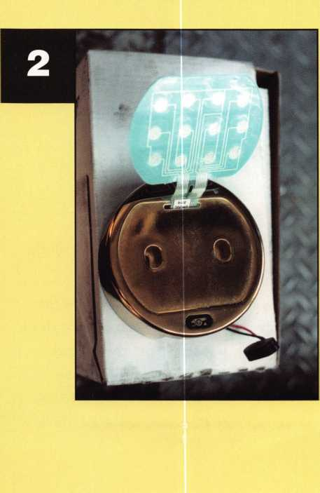

the circuit board. Once a hole is created, a wire is inserted into the lock. It is attached to the positive terminal of a 9-volt battery. The negative side is attached to the safe; usually a dial mounting screw is reinstalled to attach the negative wire. I tried several different sizes and types of wire. Finally, after over an hour of trying, I used an 18-gauge wire and a borescope to see what I was doing. The click of the solenoid told me to turn the handle. Once the safe was open, I removed the back panel of the door and reinstalled the new lock. I tested the lock several times before closing the door. The customer signed off on my paperwork from LaGard and I was on my way to the next job.

But is that all? I titled the article based on the benefit of a factory calling me because of my ALOA and SAVTA memberships. This one call almost paid my yearly dues for both memberships. I receive several calls a year based on my membership. Most years, the income received from factory calls exceed the dues. When you add the other benefits like Keynotes maga­zine, Safe and Vault Technology, the tech bulletins from SAVTA, and the other benefits these organiza­tions offer - including advocacy in local and federal governments, convention and education discounts, etc. — they make for a great investment. Q

A close up of the lock body with the hole  
drilled to access the circuit board.



This is a different lock with a similar circuit  
board. The solenoid connection is the ring  
seen toward the top.

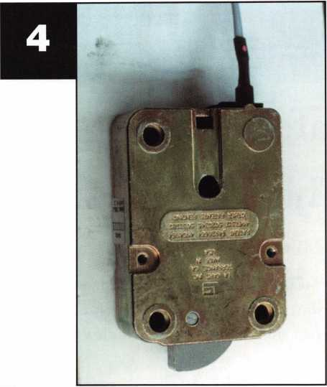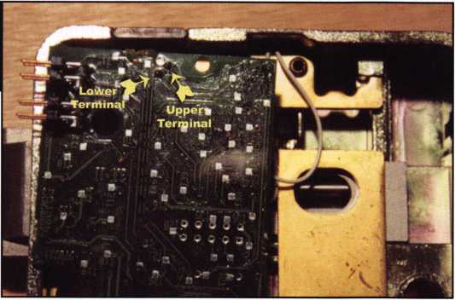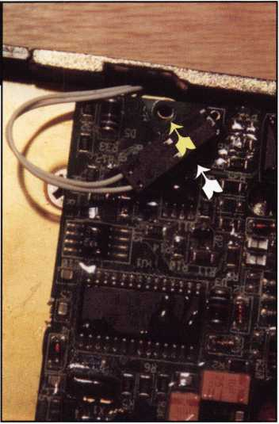

Back side of the curcuit board. The 3 solder terminals for the solenoid  
can be see. Connecting a positive lead to the lower terminal opened  
this safe.

Keynotes • May 2002

Safe Servicing Techniques:

The Major TL-30 Money Chest

By Milton Wolferseder, RL

The Major TL-30 rectangular door money chest has  
a locking arrangement that is entirely unique and  
different from any other safe. This is a steel plate

safe with a solid steel door,  
which is 1 1/2 “ thick.

(See photo 1 for view of  
door.) The McDonald’s fast  
food chain uses may of these  
safes in various locations.

The combination lock is a  
standard S&G 6700-group 2,  
mounted right hand. Looking  
in from the outside, the lock  
bolt faces left and the drop-  
in takes place in the standard  
12 o’clock position. (See view  
of lock and cam on photo  
#2.) Note that the handle  
cam strikes the lock bolt  
from underneath. The cam  
itself is a very unique fixture.

It performs four different

functions. (See actual tracing of the Major Cam in fig-  
ure 1.) The tip or the nose of the cam strikes the lock  
bolt. The heel of the cam bosses the hinged block.

The slot in the cam activates the vertical scissor bar, and the disc-riveted to the cam serves to allow the handle to move the cam. Please note that the rivet in the disc attached to the cam is designed to shear off if abnormal pressure is wrought upon the handle. In this

situation, the handle would free spin and disengage  
itself from the cam. The slot in the cam engages the  
vertical scissor-action bolt activator. Each of the four

bolts is connected to a plate  
that has slanted slots cut into  
it. As the cam turns, it acti-  
vates the vertical slide up and  
down, which in turn slides the  
door bolts in or out. The heel  
of the cam, when it is down  
and in a locked position, keeps  
the hinged blocked in and  
tight against the vertical slide  
bar, preventing that bar from  
moving. When the combina-  
tion lock bolt is retracted, the  
handle cam is allowed to move  
upward. As it moves upward,  
the heel of the cam releases its  
hold on the hinge block, which  
is spring-loaded and shifted  
backward to allow the vertical

bolt bar to move upward. All the movements are nec-  
essary for this safe to open. The relocker plunger is  
placed under the combination lock and is held in a  
cocked position at a multi-faceted plate fastened to  
the lock box cover. If the lock is punched and burglar-  
ized, the retainer releases the spring-loaded plunger,  
which in turn smashes into the rear of the holding  
block. The spring is severe and does not allow the

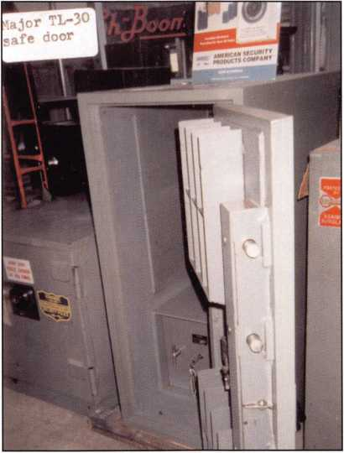

Keynotes • May 2002

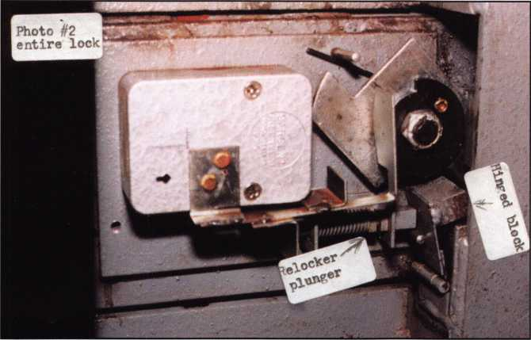

bolt to move. Even with the lock completely off,  
the handle cam cannot move to open this safe with  
the relocker fired, and it cannot be shifted back out  
of the way The square-shaped plunger fits into an  
exact square bearing hole, and when the plunger  
moves out of the square hole, it locks into a slot  
cut out for the purpose of deadlocking. Further,  
the relocker retainer also elevates upward to cover  
the handle cam. If the handle cam is punched, it  
shifts the retainer out of position and releases  
its hold on the relocker plunger.

There are several ways of opening these TL-30S,  
depending on how and why they are locked up.

Here are some considerations:

In the case of a lost or unknown combination,  
when the safe is in normal mode, try  
manipulation. Group 2 locks can be

manipulated. If this procedure fails, then  
drill for the wheels. Pull the dial with any  
good quality dial puller, remove the dial  
ring and drill a 1/4” hole one inch out  
from the dial center at 95. Drill through 1  
1/2” of solid steel, switch to carbide drill  
bits, then through a hardened steel guard  
plate (about 1/8” thick). Entering the  
Zamack lock box, proceed slowly and  
deliberately so as not to lunge into the  
wheels upon breakthrough. Install a tem-

porary dial on the remains of the  
spindle shaft and dial the safe open.

If the lock is punched and the safe  
is burglarized, drill for the relocker  
plunger. Drill a 1/4” hole (or larger if  
needed) 1 3/4” down from the handle  
center and 1/4” to the right. Once  
sighted, don’t try to slide it back,  
because it won’t go. The best thing  
to do is smash it inward and knock  
it out of the way.

If there is a malfunction within the  
lock itself and it will not dial open,  
you can drill for the tip of the handle

cam, and along with it, a corner of the lock bolt. Drill  
2” right of the handle center and 1/2” down. Sight the  
cam tip and the lock bolt and run the drill bit straight  
through, cutting out a little of each until the cam  
turns upward.

If the shear screw snaps off and the handle comes free (spinning and disconnected), drill around the side of the safe. Measure down from the handle center 1 1/2”. Carry this line over to the side of the safe and, using that plane, measure back along the side 2 1/2”. Sight the hinged block and use a long thin probe to push in on the block. This will move the handle cam, which in turn moves the vertical bolt bar, retracting the bolts. Q

Shear Screw

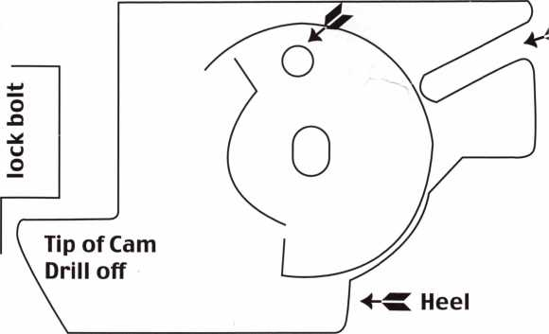

Keynotes • May 2002

Blazing Through the New

2002 Chevy Trailblazer

By Jeff Trepanier, RL

As the SUV craze continues to unfold,

Chevy recently unveiled its all-new  
Trailblazer for 2002. As far as the  
whole SUV family is concerned, the  
body styles don't present drastic  
differences for locksmiths servicing  
them. But the new Trailblazer has a  
few different twists and turns that  
are worth studying. Let’s take a look:

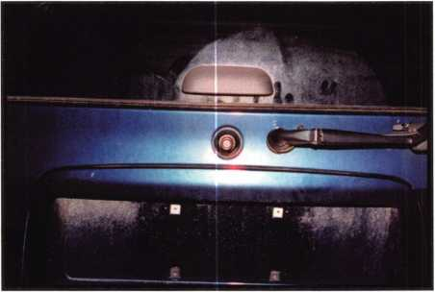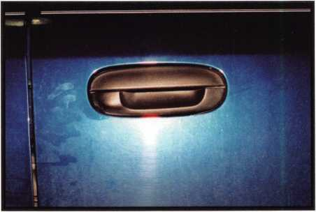

1. Close-up of the rear hatch push-button. Note there is no  
longer a keyway for the rear lock.

2. Passenger's side door handle with no door lock.

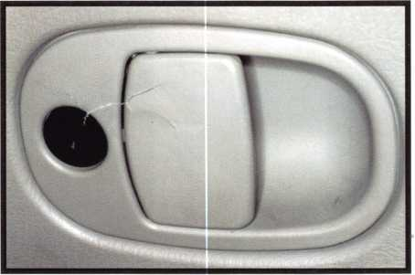

1. Close-up of the glove box lock and handle. The keyway is up and down, indicating the unlocked position. This lock can be picked. A quarter turn clockwise will lock the glove box.

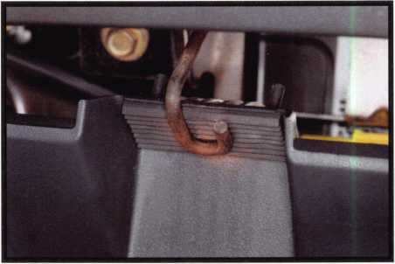

1. Shows the stop at the back of the glove box located in the center. By lifting up on this U-shaped wire, you will be able to fully open the glove box for further disassembly.

Keynotes • May 2002

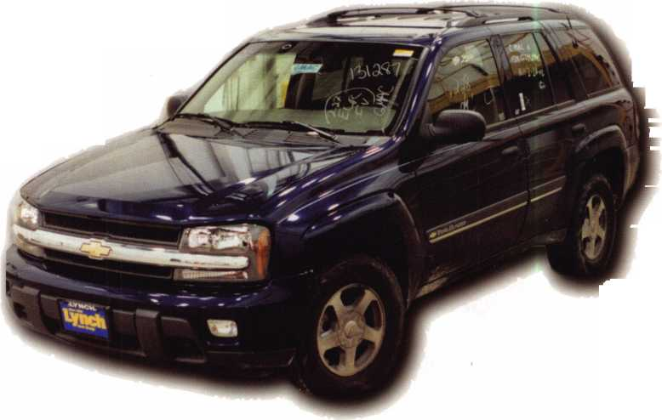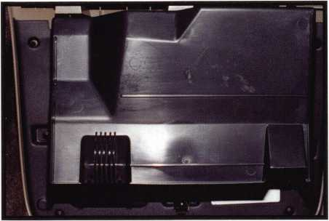

1. Shows the glove box fully opened. Also seen are seven Phillips screws that need to be removed. Now you can remove the cover.

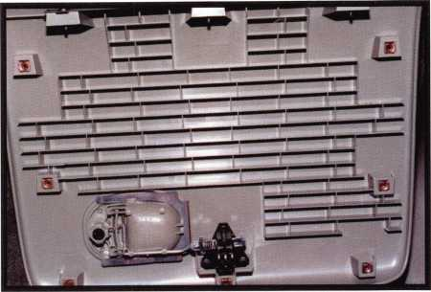

1. Shows the glove box cover removed, exposing the locking handle assembly and the latch.

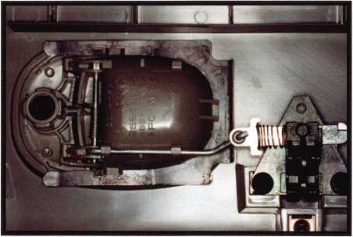

7. Close-up of the locking handle assembly and the latch.

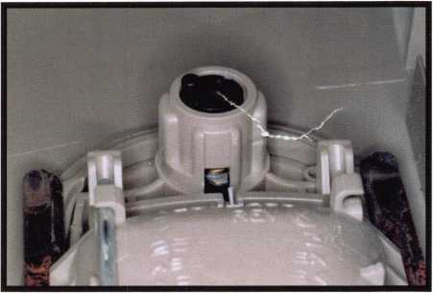

1. Close-up of the back of the glove box lock in the locked  
   position. Also seen here is the silver color retainer (center of  
   photo) that has to be pushed in and the glove box lock  
   picked again and turned a quarter turn.

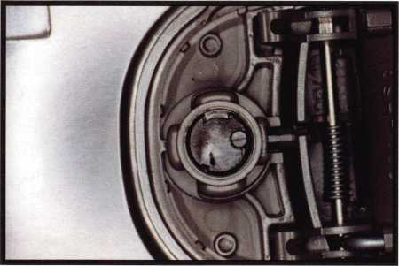

1. Shown is the position of the locking plug to be removed from the housing by simply pushing forward from the back. Note that the cut-out in the black lock plug must be lined up with the housing retainer for easy removal.

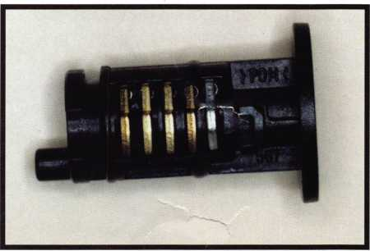

1. The glove box locking plug with four wafers and the retainer. The wafer positions are 7, 8, 9 and 10.

Keynotes • May 2002

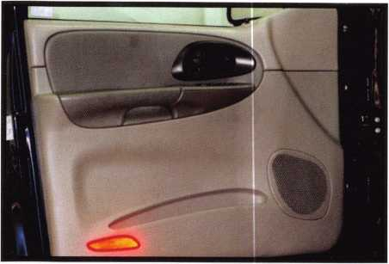

1. The driver's side front door panel. There is a reflector on the lower left corner of the panel. This is not a light, so there is nothing to unplug.

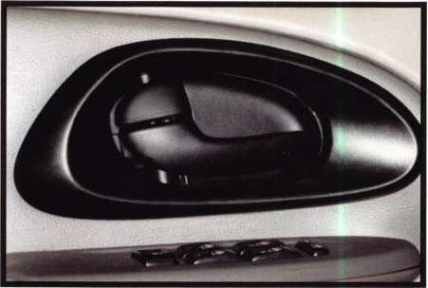

1. The door handle release and the control panel.

To remove the panel, we start by gently prying up at the  
front of the control panel.

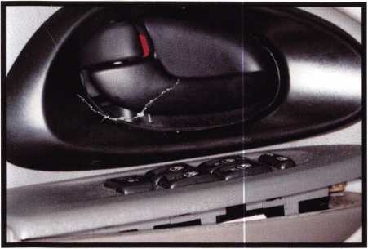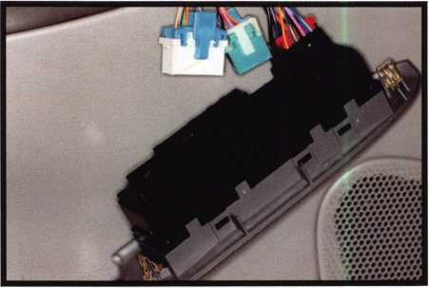

1 3. Shows the control panel partially removed. There are two clips - one at the front (seen here) and one at the rear.

1. The control panel hanging down with most of the plugs removed. Unplug the last one to completely remove it.

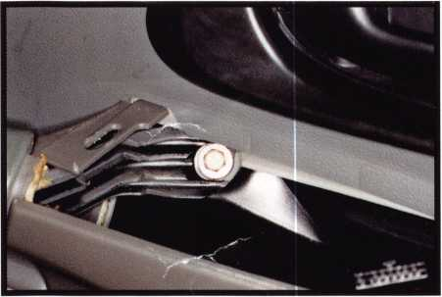

1. The 10mm screw exposed after the control panel has been removed. Remove the screw.

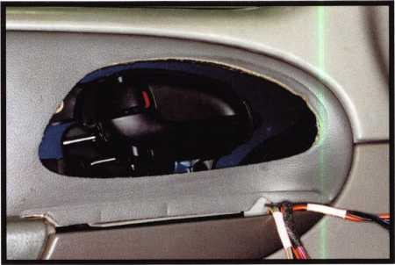

1. The control panel and door handle trim removed. To remove the handle trim, gently pry it out. It just snaps into place.



Keynotes • May 2002

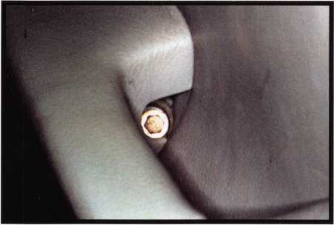

1. The second 10mm screw that needs to be removed. This is located at the rear of the door pull cavity. Now the door panel can be removed by using a door panel too. The panel is held in place by plastic retainers.

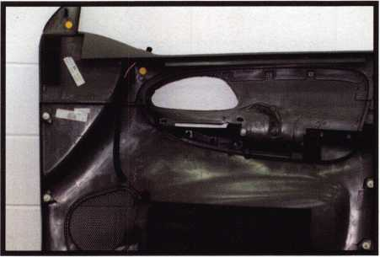

1. The inside of the door panel. Not shown here are three retainers at the bottom of the panel.

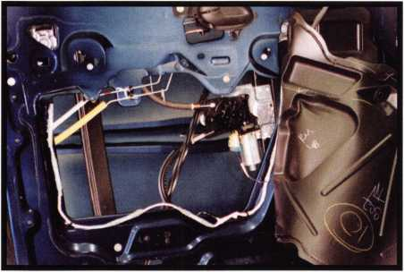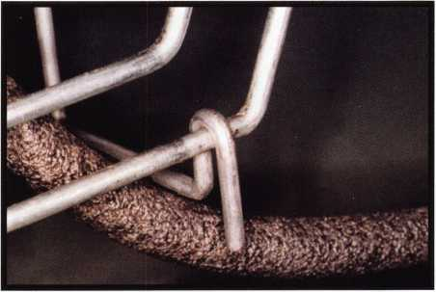

19. The inside of the door panel with the door skin partially  
pulled away.

20. The vehicle opening tool on the lock rod. This rod  
is approximately 18" down from the top edge of the door  
and approximately 10 1/2" from the edge of the door.  
Once the tool is on the rod, twist to bind the opening tool  
on the rod and move it forward toward the front of the  
vehicle to unlock.

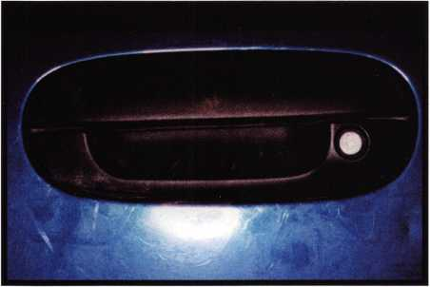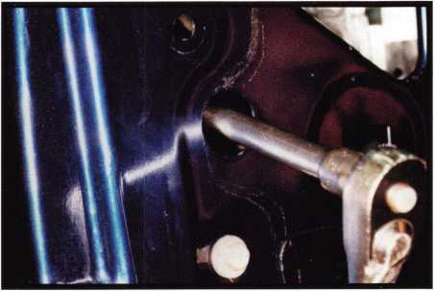

21. The driver's outer door handle and lock.

1. The removal of the first 10mm nut, for door handle removal. There is a second 10mm nut that needs to be removed; it is located to the right of the first nut (hidden). You will need a wrench to remove this nut and disconnect the rods. Now you can remove the handle.

Keynotes • May 2002

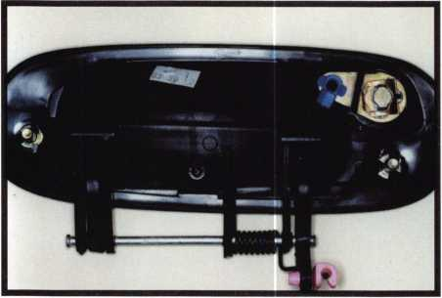

1. The door handle removed. To remove the door lock cylinder, spread open the U-shaped retainer and remove the lock, or remove the retainer first (be careful not to lose the retainer), and then the lock.

25. The door lock cylinder disassembled. Top row from  
left to right: door lock cylinder housing, door lock plug  
with seven wafers and a ball bearing and the face cap.  
Bottom row from left to right: door lock cylinder retainer  
clip, locking prawl, and door lock cylinder assembly retain-  
er. The wafers are in positions 3, 4, 5, 6, 7, 8 and 9.

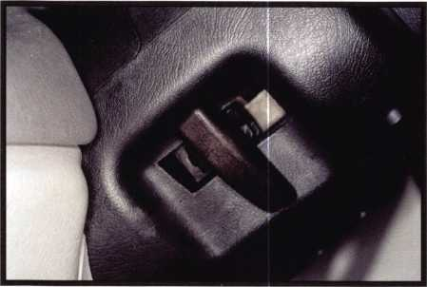

27. The tilt lever release on the left side of the steering  
column. To remove the ignition cylinder, the first step is  
to gently pop out the tilt lever.

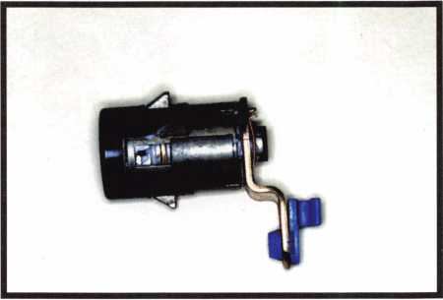

1. The driver's door lock cylinder removed. To disassemble, you first remove the retainer from the back and gently remove the back face cap. The face cap is re-usable. Remove the tail and slide the lock plug out of the housing. Be careful not to lose the ball bearing, which is spring-loaded.

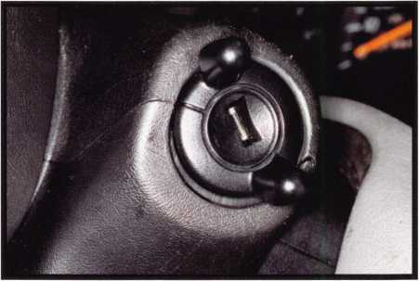

26. The ignition cylinder on the right side of the  
steering column.

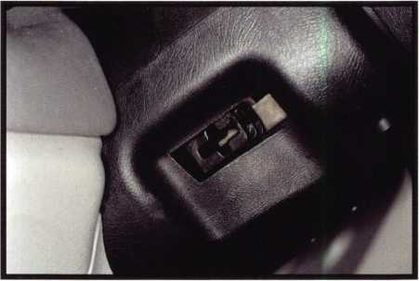

28. The tilt lever removed. Next, you gently separate  
the steering column shroud. There are no screws holding  
the two halves together. The upper and lower column shroud  
snap together. Once separated, you can completely remove  
the lower column shroud. There is just one screw holding  
the upper column shroud to the steering column. You need  
a reverse torx socket number E5. IF you do not have such  
a socket, you can use the 4mm six-point nut driver supplied  
with you're A1 GM 10-cut pick set. Now you can remove  
the upper column.

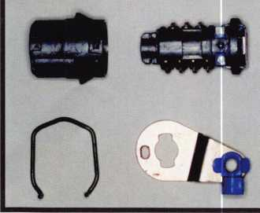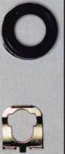

Keynotes • May 2002

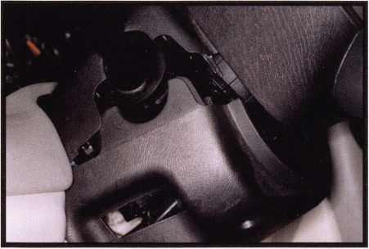

29. The upper and lower steering column shroud separated.

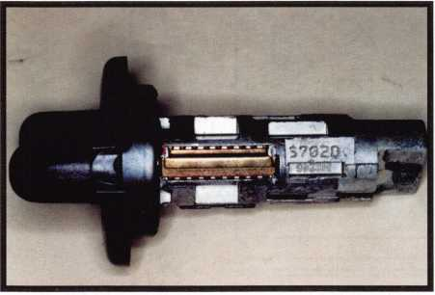

31. The ignition lock plug removed. Note the key code is  
stamped on the plug to the right of the retainer. The code  
is S70ZD.

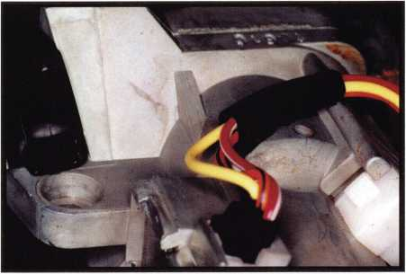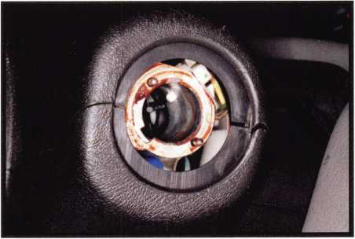

30. The top of the ignition cylinder housing with the column shroud removed. Also seen here is the poke hole to push on the ignition cylinder retainer. Before you remove the ignition, you must properly and safely disconnect the battery. Turn the ignition to the crank position (either picked or with a key), push down on the retainer and pull the ignition plug out.

32. The ignition cylinder housing with the ignition removed.

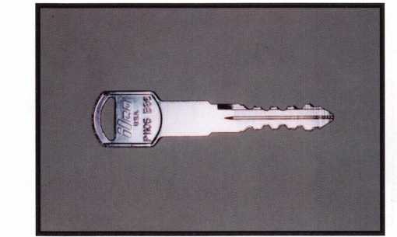

33. The cut key.

Conclusion

If we had to make a key, we would use the Al pick and go after the ignition cylinder. Depending on skill and ability, you should have a key made in 30 to 45 minutes. The door panel, in my opinion, is easy to remove and can be done in 15 to 20 minutes, and again, the door opening is easy. [J

Keynotes • May 2002

**2**

Beginner’s Corner  
Pinning Lock Cylinders

By Merritt Perkins,

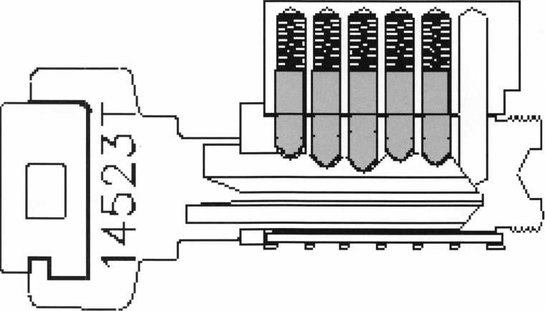

One of the jobs that locksmiths do frequently involves the repinning of pin tumbler cylinders. Instead of replacing the entire lock so that the old keys will not work, new keys can be cut to a different combination and the lock taken apart and pins insert­ed to fit the new keys. If two or more locks of the same make and keyway are pinned alike, the same keys will fit them all.

Locks made today are manufactured by the thousands to standardized dimensions so that parts are inter­changeable. The shape of the key cuts, spacing, depths of the cuts, and corresponding lengths of the pins are all standardized. The tolerances of how much the dimensions can vary and still work were deter­mined when the locks were designed. Better quality locks are made of better quality materials to closer tolerances and are fitted more accurately. Let’s take a look at a few types.



Keynotes • May 2002

Set screw groove

3-48

0.025" clearance

Cam

X 0.360"

screws

Adams Rite

Cam

sheet metal cut from a tin can bent  
to fit tightly over the plug can be slid  
on the plug to hold the pins in place  
while it is set aside.

KEY IN KNOB CYLINDER

ooooo

PLUG

FOLLOWER

MORTISE CYLINDER

A typical mortise cylinder is 1-5/32 inches in diameter with 32 threads per inch and is used with mortise locks, the length varies from 1 to 1-1/4 inches or more depending on door thickness.

A typical pinning job may be on a mortise cylinder using .115 inch diameter pins. The two flat-head machine screws holding the cam to the back of the plug are removed, and the cam taken off.

To take the cylinder apart insert the key, turn it slightly, and holding a follower (transfer plug) against the back of the plug slide the follower in and the plug out of the cylinder. The follower will hold the driver pins and springs in place in the pin chambers.

The plug needs to be held with the pins on top so that they will not fall out and get mixed or lost. Put the plug with pins and key in a plug holder. A piece of

This type of cylinder may have a  
retaining ring that fits in a groove in  
the plug to hold it in position and  
possibly a driver attached to the end  
of the plug to actuate the locking  
mechanism. Another variation has a  
threaded cap that screws on the end  
of the plug and a spring loaded pin  
that fits into scallops to keep it from  
turning.

When the right key is inserted the  
top of each lower pin is flush with  
the surface of the plug and the driver  
pin rests on it but is in the upper pin  
chamber with a spring above it to  
keep the driver pressing on the lower  
pin or surface of the plug. In master  
key systems, master pins are inserted

between the bottom and driver pins so that one key  
will operate the lock if the master pin is in the pin  
hole in the plug and another key if it is in the pin hole  
in the cylinder housing.

To hold the upper springs and pins in place we need a follower (transfer plug) the same diameter as the plug that fits over the tailpiece and is kept pushed against the back of the plug so that the driver pins do not drop between them as the follower moves in and the plug moves out.

When a key is inserted in the keyway in the plug, it raises the lower pins so that their tops are at the shear line (the top surface of the plug), and the key and plug can be turned.

For servicing purposes, the plug is placed in a plug holder and a key blank inserted to raise the pins so

Keynotes • May 2002

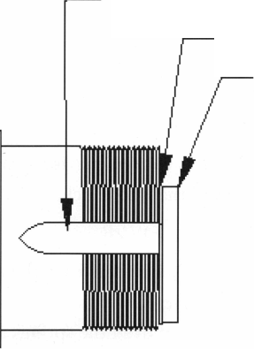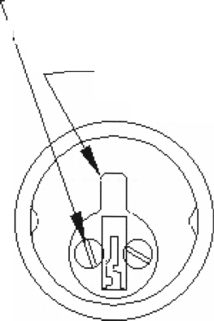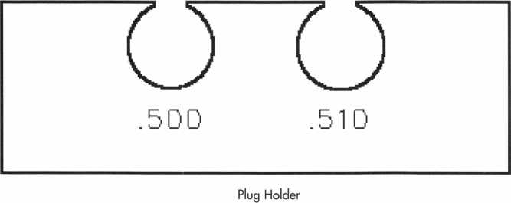

plug and cylinder, using a pipe  
cleaner and naphtha to remove  
any oily accumulation, dirt, or  
excess graphite from the pin  
holes. Naphtha is conveniently  
purchased as lighter fluid and  
the can is convenient for squirt-  
ing naphtha into a lock.

SPRING COVER

that they can be lifted out with pin tweezers and placed in a holder and gauged or measured and a record kept of their lengths in case we may need this information. Holders for pins and lock parts are sold by supply houses. The pin holder can consist or a strip of corrugated cardboard with the top corru­gations open and fastened to a piece of wood so that it will not move around.

To remove the driver pins and springs, position the cylinder with the pin chambers down, slide the fol­lower slightly endwise so that one pin is partly uncovered, hold the tip of your pin tweezers on it, pull the follower out enough that the tweezers can let the spring push the pin part way out of the hole, press the follower against the pin to hold it, grasp the pin with the tweezers, move the follower away slightly and lift the pin out and put it in the pin holder. If the springs come part way out, put them in the pin holder too. If the springs remain in the upper pin chambers, remove the rest of the pins in the same way and then remove the springs. Sometimes springs stick in the pin chamber and by straightening out a paper clip and bending the tip to form a hook a tool can be made to help remove them.

Springs can be handled with pin tweezers or with special spring tweezers with thin tips and an adjust­ment to keep the tips from spreading wide enough to grasp two turns of the spring which could result in the spring flying out of the tweezers. Clean the

Some lock cylinders have the top ends of the pin chambers covered with a spring cover. If the spring cover is removed the springs and pins can be removed without removing the plug. Some mailbox locks with a spring cover have an extra pin hole in the back of the cylinder for a retainer pin which fits in a groove or slot in the plug and acts as a retainer and to limit the rotation. (The retainer pin would prevent insertion of a shim between the plug and cylinder to keep the lower and upper pins separated. These locks are usually not taken apart but are replaced.)

If the key is not available to use in taking the lock apart, it might be possible to pick it and turn the plug, but an easier way is to shim it.

SHIMMING A LOCK

Insert a key blank all the way into the keyway and insert a shim into the back of the cylinder until it presses against the last pin. Grip the key blank between the thumb and forefinger with the finger tips against the face of the plug so that as you bend the joints of the thumb and forefinger, you slowly withdraw the key blank. The pin rests on the slope on the tip of the blank and is gradually lowered while you rapidly jab the shim against the lower pin and pull it back slightly so as not to bind the pin with the pressure of the shim against it until the blank is withdrawn far enough for the shim to go over the top of the lower pin and between it and the pin above it (the driver pin, or maybe a master pin). Push the shim against the side of the next pin

Keynotes • May 2002

LOCK PINS

Mi

■■1 h./l

3

y

**BBWWj**

s

The shim is starting to enter ' between the bottom and driver pins.

|  |  |  |  |  |
| --- | --- | --- | --- | --- |
| i  ■  iw | 1 | i |  | The shim is now between the bottom and driver pins and is |
| K J | V |  | contacting the next pins. |
|  | |

N

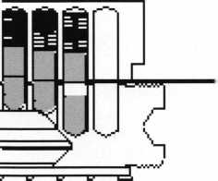

The key is withdrawn, allowing the fourth pin to drop slightly. The fifth bottom pin has dropped ■ to the bottom of the pin hole in the plug.

The driver pins usually have both ends flat with perhaps a slight chamfer. Master pins usually have both ends flat with a cham­fer. The top of the bottom pin is flat with a chamfer or with a radius to fit the curvature of the outside of the plug. The bottom of the bottom pin which fits in the cut in the key was hemi­spherical or ball shaped on some early locks. Later pins were cone shaped with a 45 degree angle and a small flat at the bottom. Pins with a radius coming to a point at the tip were used on many locks. A notch in the key with a bottom 0.050 inch flat and 45 degree angle sides allows for some variation in the spacing of the pin holes. Another design has bottom pins with a large flat at each end that can be inserted either end up used

and, slowly withdrawing the key blank, keep back­ing up the shim slightly to allow the pin to drop. Then push it against the pin until the shim enters between the lower and driver pins. Push the shim in until it contacts the next pin and proceed to insert the shim between the lower and upper pins until the key can be turned. Keep the key turned, press the follower against the back of the plug and pro­ceed as previously described. You may be able to insert the follower and remove the plug with the shim in place.

If the cylinder has master pins be very careful as they might be either in the plug or the cylinder pin chamber or both, and it is critical not to lose this information which determines the cuts of the mas­ter and change keys.

with keys with a wide flat at the bottom of the cut, i.e., Kwikset or Weiser.

With the plug in the holder, load the bottom pins and with the key inserted it can be tried to see if it fits. If you have a comparator stand or Granit Chek, (a block of flat granite as a base and a column to support a dial indicator), the plug holder can be slid on the base so that the point of the indicator rests on the top of each pin to compare the height of the pins with the surface of the plug to determine how much they are low or high (if any are high the plug will not turn freely in the plug holder). If the pin is not flush with the surface the error may be in the length of shape of the pin or in the shape, depth of cut, or spacing of the cuts of the key

Keynotes • May 2002

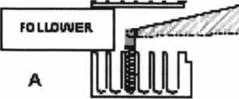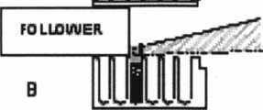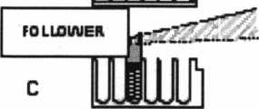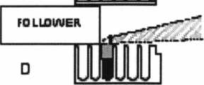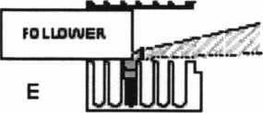

1 fcllll

FO L LOUVER.

Jkmmkm

**iTBiiri**

1. Insert spring and driver pin in pin chamber
2. Grip pin with tweezers and start into the pin chamber
3. Release tweezers and remove. Close tweezers and press on end of pin.
4. Pull back slightly on follower and push pin all the way into the pin chamber with tweezers.
5. Pull back slightly with tweezers and push on follower to slide over end of pin.
6. Tweezers removed, follower all the way over the driver pin. Ready to load the next pin chamber.

of the spring and hold it while you  
press the follower against the pin  
to hold it, move the tweezers to  
the end of the pin, release the pres-  
sure of the follower against the pin,  
press the pin into the pin chamber  
compressing the spring, and slide  
the follower over the end of the  
pin pushing the tweezers out of the  
way Continue to load the other  
upper pins the same way It may be  
easier to start by loading the mid-  
dle pin first and then working  
toward one end, then the other.

When loading master pins it may  
be easier to load the master pins in  
the plug and only the springs and  
driver pins in the cylinder.

TO REMOVE THE  
SPRING COVER

When pinning master keys of keyed-alike locks, a plug holder for more than one plug of the same size will make it easier to pin more than one plug at a time. Master pins may be loaded in the plug at this time.

Now load the cylinder with the pin chambers down. Insert one spring into a pin chamber, then pick up a driver pin with the pin tweezers and insert it on top

To loosen the staking use a cold  
chisel with about a 75 degree angle  
to raise the staking from the spring  
cover. It may be necessary to pry  
up the back of the spring cover by  
inserting a pointed tool or a tool  
with a slender chisel like tip 1/16”  
to 3/32” wide and to push it out the  
back. Care must be used to prevent  
damaging the springs. As the  
spring cover is removed the springs  
may tend to jump out when  
released, so while removing the

spring cover keep the cylinder covered and release the  
springs slowly.

A cover that snaps over the top of the plug was used  
on other cylinders. This cover is held in place by  
grooves on each side of the upper part of the cylin-  
der. The cover may slide on from the end or push  
straight down. When sliding the cover on from the

Keynotes • May 2002

end use the tip of the spring tweezers to hold the top of the spring down so that the spring cover will pass over the spring.

It is best to have a keying kit provided by the lock manufacturer for each of the locks that you frequently work on. These keying kits contain the right pins, springs, special tools, and many small parts that are not available other­wise and are just what you need to replace a broken or missing part and complete a job. It is a problem to know which keying kits to have for you could have kits that you would never use.

Most of the locks that locksmiths work on use about 0.115 inch diameter pins. Pins are available in packages of 100 pins of a given size, and in large sets of pins in steps of .005 inch or even .003 inch length.

If you get a new keying kit the pins and springs may be packaged 100 to an envelope. The tendency of a beginner is likely to be to empty the envelopes into the pin trays or compartments so that it is easy to get to them. Once you have an accident and spill them, especially if you are outdoors and hurrying to finish a job while people are waiting for you, it will be no fun to try to pick them all up and sort them. Q

S3

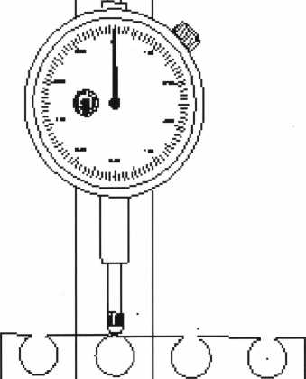

Keynotes • May 2002

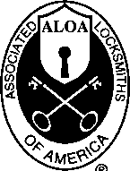

Associated Locksmiths of America, Inc.

Proxy

For Meeting Members

Dear ALOA Members:

The Associated Locksmiths of America, Inc. (ALOA) bylaws designate that the Secretary of the Association and the Northeast, South Central, Northwest, Asian, European and Associate Member Regional Directors be elected in even-numbered years. The Bylaws allow voting by proxy, a procedure that will allow all members to partici­pate in the election of their respective officers. A proxy allows you to authorize someone to vote for you at a meeting.

As President, I have called a special membership meeting at 10:00am June 14, 2002 at ALOA Headquarters, 3003 Live Oak Street; Dallas, TX. The purpose of this meeting is to elect the Secretary and Directors for the association.

The ballot is in the form of a proxy, prepared for you to give specific instruction to the holder of the proxy.

This will ensure that your vote is counted exactly as you desire. You must provide your name, member number, and date and sign the form. Failure to properly complete the proxy may result in your ballot being invalid.

Please vote for Secretary and your Regional Director only. Write-in candidates are not allowed and there will be no one "running from the floor" at this special meeting of the membership.

Please tear out the enclosed proxy and mail or fax as soon as possible. In order for your vote to count, the holder of your proxy, as designated below, must be present at the meeting and have the properly completed proxy with him. This means that your ballot must be received no later than Wednesday, June 12,2002. You do not have to designate J. Timothy McMullen, Esq. as your proxy. You may give your proxy to anyone else, but they must attend the special membership meeting on June 14, 2002 with your signed and dated proxy in hand.

Please participate in the future of your association!

Sincerely,

ASSOCIATED LOCKSMITHS OF AMERICA, INC.

Randy L. Simpson, CML President

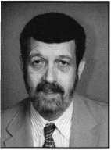

Secretary

John D. Cannon, CML

John is currently serving as the Secretary of ALOA, after serving five years as the Northeast Vice President of ALOA and as a Director prior to that. At  
various times, he has held the Chairmanship of the Education, Publications, Finance, and Personnel Committees, as well as being Vice Chairman of  
many other committees. He has also served as a member of the SAVTA Board of Directors and Chairman of the SAVTA Education Committee. Prior to  
his service with ALOA, he was the President of the Locksmiths’ Association of the Washington, DC Area, as well as Chairman of the Washington D.C.  
ALOA Chapter #5. Cannon is the owner of Locks Unlimited, Inc. in Alexandria VA, and also manufactures specialty tools for the safe and vault indus-  
try. For several years John has instructed safe deposit box lock classes for ALOA, SAVTA and many other regional associations.

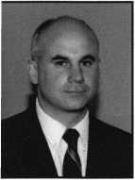

Northeast Regional Director

William Young, CML

Bill began his career in locksmithing at the age of 13. After earning a degree in business administration from Mars Hill (NC) College, he entered the industry full time.  
Bill became owner of A1 Security Center in Malvern, PA.

Bill has been actively involved in the Greater Philadelphia Locksmiths Association (GPLA) since 1985. He has served that association as president, board chairman,  
vice-president, secretary/newsletter editor, and is currently a director. He has been a member of ALOA since 1987 and a member of SAVTA since 1989. Bill is currently  
serving his second term as ALOA Northeast Director.

various trade publications

Together with his GPLA membership, Bob is a charter member of the South Jersey Locksmiths Association, an honorary member of the National Locksmiths Association  
of Canada and a longtime member of the Associated Locksmiths of America. In addition, he is a Founder Member of the ALOA European Chapter. Among his other  
endeavors are serving on the Board of Directors of the Gerald J. Connelly Memorial Library Foundation, functioning as Curator of the GPLA Library, writing articles for  
and teaching classes.

Peter Sarailian, CRL

Pete has been a locksmith for 28 years and an ALOA member since 1976. He’s served as Treasurer of the Master Locksmiths Association of New  
Jersey from 1994 until present and was president of that organization in 1987. Pete owned his own business from 1974 until 2000, when he sold it.  
He is currently employed with Safemasters in Little Falls, NJ, as material coordinator and inside tech.

Robert Mock

Known to fellow professionals as the Frugal Locksmith, Robert Mock has been “on the road” in the security industry for more than 25 years. As a student and mentor, he  
has traveled to confer with other expert locksmiths from around the world. Coming from a unique perspective of both business owner and employee, Bob has accumu-  
lated a wealth of practical information which only experience can provide.

Mr. Mock is currently serving as a member of the Board of Directors of the Greater Philadelphia Locksmiths Association. He has served as Chairman of the Board for six  
years. He held the post of President for eight years. He has also occupied the positions of Vice President and Corresponding Secretary for the GPLA and he generally  
serves as their Ambassador of Good Will.

The "bobfather”, as he has been dubbed by his cohorts, has been honored by the Master Locksmiths Association of Great Britain; he has twice accepted the Herman C. Henssler, Jr. Memorial for Outstanding Effort, and has received the Lee Rognon Award for Promoting Cooperation Among Associations.



Association (PLA), and

Northwest Regional Director

Scott Henke, CPL, CPS

Scott, a lifelong Alaskan and a second-generation locksmith, has been a member of ALOA since 1982. He currently serves on the ALOA Board as  
Northwest Director and on the Strategic Planning Committee. In 1998, he was appointed to serve on the Audit Committee. Scott attended his first ALOA  
Convention in 1982, where he earned his CRL certification. A member of Safe and Vault Technicians Association (SAVTA) since 1988, he earned his  
Certified Professional Safetech (CPS) certification during its first offering in 1994. He currently serves on the Advisory Board for Security Solutions. In  
addition, as a member of Northwest Locksmiths Association (NWLA), he gained NWLA certification in 1983. His other memberships include the fol-  
lowing: National Safeman’s Organization, (NSO), National Independent Bank Equipment & Systems Association (NIBSEA), Pacific Locksmith

American Society for Industrial Security (ASIS).

As President and CEO, Scott is leading his family’s business, Action Security, Inc., in an increasingly diverse security market. He oversees company-wide operations of Alaska’s largest and most sophisticated security provider. Established in 1963, Action has four locations located throughout Alaska, an inventory of one million dollars, a staff of 50 employees and 30 service vehicles. His duties include overseeing five different operations: a banking division; a contract hardware division; an electronic division; a retail secu­rity division and a wholesale division.

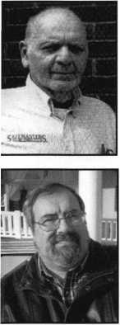

South Central Regional Director

C.D. Lipscomb, CML, CPS

C.D. operates Navco Safe And Lock Co, Inc., a full service, storefront locksmith shop with multiple outside service vehicles servicing the Central  
Texas area. He is an active member of the Associated Locksmiths Of America (ALOA), the Safe And Vault Technician’s Association (SAVTA), the  
Texas Locksmith Association (TLA), the Greater Dallas Locksmith Association ( GDLA), the Metroplex Locksmith Association ( MLA), the  
Oklahoma Master Locksmiths Association ( OMLA), the Clearstar Online Locksmith Association ( COLA), and has served on the executive boards  
of several of these organizations. He has been awarded a life membership in the Greater Dallas Locksmith Association, and the prestigious Bill  
Reed Award for outstanding service to associations and the profession of locksmithing. C.D. currently teaches various locksmithing classes for  
ALOA, TLA, several local locksmith associations, and serves as moderator for Locksmith.com, an online locksmith forum. He is a Certified Master

Locksmith, and Certified Professional Safetech.

C.D. is married to Jean Lipscomb. After 35 years together, they have three grown children, and one grandchild. They reside in Eureka, a small lakeside community near  
Corsicana, Texas, and are members of Mildred Baptist Church. Mr. Lipscomb graduated from Mildred High School and Navarro College in Corsicana. He has worked and is  
skilled as a construction engineer, carpenter, contractor, locksmith and safe technician, and has actively worked in the field of physical security for 28 years.

C.D Lipscomb believes in education, co-operation, and advancement of the industry through association. He is currently running for the South Central Directorship of ALOA  
in order to further serve his fellow locksmith and his chosen industry.

Asian Regional Director

Joe Lee, CRL

Has been in the locksmith trade since 1994. Has been a regional sales rep. for ASSA, Securitron, H.E.S, ALL LOCK etc. Has served the ALOA mem-  
bers in Asia as their liason between ALOA. Is current the president of Access Security technologies.

European Regional Director

Hans Mejlshede, CML

Hans has been an active member of ALOA since 1974, attending all ALOA conventions, and an ALOA instructor for more than 20 years. For many  
years, he was the ALOA co-chairman of international affairs. He has been honored with the The Lee Rognon Award (1984), the ALOA President’s  
Award (1986), and the GPLA Award (1987).

Currently, Hans is President of the Danish Locksmith Association. For eight years he was the President of The European Locksmith Federation, and  
is now the honorary president of the same association. He has a Masters Degree in Mecanical Engineering from the University of Copenhagen. He is

from a locksmithing family, and has been a locksmith all of his life. For many years Hans has been pushing ALOA to have an International Director because more than 10% of  
the membership lives outside the United States. Now the bylaws have been changed and he is seeking the new office of European Director. He has, in the past four years, been  
an appointed board member of ALOA. He would like to create a shop certification program for the ALOA membership, and would like to make a membership drive in Europe  
and work to expand more European locksmiths to the ALOA education programs offered.

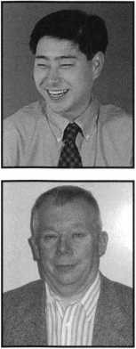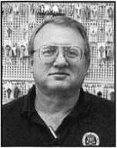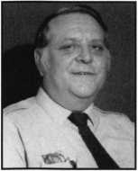

Ron Cliff

Ron Cliff has been in the locksmithing trade since 1978 and is the sole proprietor of Greenford Security Services, Ltd. In 1980, he became a corpo-  
rate member of the Master Locksmiths Association and a Fellow Member in 1983. He held the position of London Regional Secretary in 1987 and  
1988 and served as Chairman in 1988 and 1989. His terms of Office as National Council Member (governing body of the M.L.A.) were 1984-1987  
and 1990-1995. He has also served on the following MLA sub-committees: Premises Committee, Technical Committee, Intake Committee and  
Training Committee. He is also a certified lecturer.

Currently, Mr. Cliff is the Secretary for the London Region of the Master Locksmiths Association and was the MLA representative on British  
Standards Vehicle Security. He has also assisted the MLA with training programs and NVQs. He was the Senior Sold Secure Attack Team Member  
(mechanical) and his own test facility, The Security Test Centre, was licensed by Sold Secure to undertake New Vehicle Attack Testing.

He is registered with the Law Society as an Expert Witness and is a member of the Expert Witness Institute. He is consulted as an Expert Witness by Police and the legal pro­fession both in the UK and overseas. Mr. Cliff is also a member of the following organizations: ALOA, European Chapter of ALOA, IAATI, International Association of Investigative Locksmiths, Canadian Locksmith Association. He received the Chubb Award for 2001.

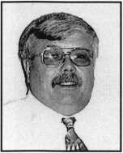

Associate Member Regional Director

Paul M. Justen

President and owner of Doyle Security Products located in Minneapolis, MN. Have been both a regular member and associate member of ALOA  
since becoming involved in the industry. Currently serves on the Board of Directors of SHDA (Security Hardware Distributors Association). Member  
of ALOA Manufacturing/Distributor Legislative Ad-Hoc committee. Also serves on the Locksmith Industry Advisory Committee. His company is also  
an associate member of all locksmith associations in the market area company services, and a member of the ALOA Legislative Action Network.

ASSOCIATED LOCKSMITHS OF AMERICA, INC.

OFFICIAL PROXY FOR MEETING OF MEMBERS

The undersigned, being the Associated Locksmiths of America, Inc. (ALOA) member indicated below, hereby appoints J. Timothy McMullen, Esq. the proxies and true and lawful attorney of the undersigned to attend the meeting of the Membership of ALOA to be held at *3003* Live Oak Street, Dallas TX *75204* on June *14*, *2002* at *10*:*00*am or any adjournment thereof, and to vote on behalf of said ALOA Member as designated below:

FOR THE OFFICE OF SECRETARY

VOTE FOR ONE (1) ONLY

(Eligible to vote: Active, Apprentice, Retired, Life and Associate members):

* John D. Cannon, CML

FOR THE OFFICE OF NORTHEAST REGIONAL DIRECTOR

VOTE FOR THREE (3) ONLY

(Eligible to vote: Active, Apprentice, Retired, Life and Associate members whose business address is in Connecticut, Delaware, District of Columbia, Kentucky, Maine, Maryland, Massachusetts, New Hampshire, New Jersey, New York, Ohio, Pennsylvania, Rhode Island, Vermont, Virginia, West Virginia, APO New York):

* William L. Young, CML
* Peter Sarailian, CRL
* Robert E. Mock

FOR THE OFFICE OF NORTHWEST REGIONAL DIRECTOR

VOTE FOR ONE (1) ONLY

(Eligible to vote: Active, Apprentice, Retired, Life and Associate members whose business address is in Alaska, Idaho, Montana, Oregon, Washington, Wyoming, APO San Francisco):

* Scott L. Henke, CPL, CPS

FOR THE OFFICE OF SOUTH CENTRAL REGIONAL DIRECTOR

VOTE FOR ONE (1) ONLY

(Eligible to vote: Active, Apprentice, Retired, Life and Associate members whose business address is in Arkansas, Kansas, Louisiana, Missouri, Oklahoma, Texas):

* Clifford D. Lipscomb, CML, CPS

FOR THE OFFICE OF AISAN REGIONAL DIRECTOR

VOTE FOR ONE (1) ONLY

(Eligible to vote: Active, Apprentice, Retired, Life and Associate members whose business address is in Australia; China; Fiji; Guam; Hong Kong;

Japan; Korea; Macao; Malaysia; New Zealand; Philippines; Singapore; Taiwan; Thailand):

* Joe J. Lee, CRL

FOR THE OFFICE OF EUROPEAN REGIONAL DIRECTOR

VOTE FOR ONE (1) ONLY

(Eligible to vote: Active, Apprentice, Retired, Life and Associate members whose business address is in Argentina, Austria, Bahamas, Barbados,

Belgium, Bermuda, Brazil, Bulgaria, Canada, Chili, Columbia, Denmark, Ecuador, Egypt, El Salvador, Estonia, Finland, France, Germany, Great Britain, Guatemala, Holland, Iceland, Ireland, Israel, Italy, Jordan, Kenya, Latvia, Macedonia, Mexico, Morocco, Norway, Panama, Papua New Guinea, Peru, Romania, Russia, Saudi Arabia, South Africa, Spain, Sweden, Switzerland, Trinidad, Turkey, Uruguay, Virgin Islands, West Indies, Yugoslavia):

* Hans Mejlshede, CML
* Ronald E. Cliff

FOR THE OFFICE OF ASSOCIATE MEMBER DIRECTOR

VOTE FOR ONE (1) ONLY

(Eligible to vote: Employee who is the designated representative to vote on behalf of the Associate Member):

* PaulM. Justen

**Print/type Name of ALOA Member**

|  |  |
| --- | --- |
| Member Number |  |
| Member Signature | Date |

This proxy must be signed and dated with member number to be considered valid. It must be received no later than June 12, 2002. Please tear out and mail/fax to:

Associated Locksmiths of America, Inc.  
Attn: J. Timothy McMullen, Esq.  
3003 Live Oak St.

Dallas, TX 75204  
Fax: 214-827-1810



The Motor Vehicle Owner's Right to Repair Act of 2001 H.R. 2735

Increasing technology in cars, including systems mandated by the govern­ment to control emissions, is allowing car manufacturers, and not owners, to determine where motor vehicles are serviced. By not providing vital codes and tools necessary to repair today's high-tech cars to the independ­ent aftermarket, manufacturers force car owners to return to dealerships for service, including having new keys made.

The Motor Vehicle Owner's Right to Repair Act of 2001 seeks to remedy this situation by ensuring the motor vehicle owner has the right to the infor­mation necessary to repair his or her vehicle, including key codes. The leg­islation does this without requiring car manufacturers to divulge proprietary information or trade secrets.

For more information and how to get involved click on: [http://www.after- market](http://www.after-market). org/Government/Grassroots_Activities/hr2735 .asp

CONNECTICUT HB5615

An Act requiring the licensing of security systems and fire alarm sellers, installers and monitors. However, nowhere in the bill does it define what a "security system" is.

STATUS:

02/28/2002 Sent to Committee on General Laws.

03/31/2002 Died in Committee.

ILLINOIS HB3663

Amends the Private Detective, Private Alarm, Private Security, and Locksmith Act of 1993; provides that a person who applies for licensure as a locksmith agency between September 1, 2002 and December 31, 2002 shall be exempt from the examination requirement.

STATUS:

11/06/2001 Introduced

1 1/07/2001 To House Committee on Rules

ILLINOIS SB 1558

Amends the Private Detective, Private Alarm, Private Security and Locksmith Act of 1993; makes a technical change to a Section concerning the leg­islative intent. Amendment would rewrite/clarify law on what constitutes "holding oneself out as a locksmith".

STATUS:

01/10/2002 Introduced

04/04/2002 Passed Senate.

04/05/2002 To House Committee on Rules.

KANSAS HB2887

An Act concerning locksmiths; providing for regulation and licensure; pro­hibiting certain acts and providing penalties for violations.

STATUS:

02/13/2002 Introduced

02/15/2002 To House Committee on Business,

Commerce and Labor 03/31/2002 Died in Committee.

MARYLAND SB 125

Continues the licensing and regulation of security systems technicians in accordance with the provisions of the Maryland Program Evaluation Act (Sunset Law) by extending to July 1, 2016 the termination provisions relat­ing to the statutory and regulatory authority of the Secretary of the State Police to license and regulate security systems technicians.

STATUS:

01/11/2002 Introduced

02/14/2002 Passed Senate.

03/29/2002 Passed House.

• Renews the Security Systems Technicians Act which is set to expire this year. Currently, there is no definition in this law about what constitutes a "security system".

MARYLANDY HB1004

Clarifies the State Security Systems Technicians Act by including the defini­tion of security system.

STATUS:

02/08/2002 Introduced

02/08/2002 To House Committee on Economic Matters

02/27/2002 Died in Committee.

NEW YORK SB 1859

Provides a possible tax credit in cities of one million or more for security improvement measures or enhancements made in class 2 dwellings; authorizes a one time credit of up to 20% of the cost of such measures or enhancements.

STATUS:

02/11/2002 Introduced

02/12/2002 From Senate Committee on Cities

CHECK OUT ALOA'S

WEBSITE AT <http://www.aloa.org/news/legcom.cfm>

FOR THE LATEST HAPPENINGS IN YOUR STATE

Keynotes • May 2002

OHIO HB452

Creates the Commission on Electronic Security System Regulation in the  
Department of Commerce. The definition of Electronic security system reads,  
"an assembly of electronic equipment and devices, which may include  
access control and closed circuit television, that for its main purpose detects  
threats, intrusions, or security violations that jeopardize the safety of life or  
property."

STATUS:

01/22/2002 House Committee on Commerce and Labor:

Heard Sponsor in Committee

01/29/2002 House Committee on Commerce and Labor:

Heard Proponents in Committee.

NOTE: The Ohio Locksmith Association has hired a lobbyist to represent  
locksmith's interests in Columbus. Your help is needed to fund this important  
venture. Go to <<http://www.aloa.org/news/lan.htm>> and donate today!

PENNSYLVANIA HB2075

Regulates the licensure of electrical and alarm system contractors.

Establishes the Electrical Contractors Licensing Board. Provides for penalties.

STATUS:

10/24/2001 Introduced

10/24/2001 To House Committee on Professional Licensure

SOUTH CAROLINA SB381

To provide for the licensure of locksmith agencies, to require employee regis-  
tration, to require signed work order forms when opening residences, com-  
mercial establishments and motor vehicles, and to provide penalties for cer-  
tain violations.

STATUS:

02/27/01 Introduced.

02/27/01 Referred to Committee on Labor,

Commerce and Industry.

03/31/02 Died in Committee.

Copies of all these bills can be found at  
[www.aloa.org/news/legislation.cfm](http://www.aloa.org/news/legislation.cfm)

**JOIN**

**THE LEGISLATIVE  
ACTION NETWORK**

**TODAY!**

As we continue to expand  
our resources and become more  
competitive in the legislative arena,  
we need the monetary resources to  
match our successes You can help  
with as little as $24.95 to the  
Legislative Fund. This is only the  
minimum that we are asking, and  
encourage you to give more if you  
can. Those that contribute will be  
given a Legislative Action Network  
Member kit to use in their grass  
roots efforts. Members who donate  
$100 or more become Legislative  
Action Network Council members,  
and enjoy the following extra bene-  
fits: Discounts on ALOA bookstore  
items; 10 % rebate on all ACE  
classes; Complimentary Legislative  
Convention merchandise

Join today by going online at:  
<http://www.aloa.org/news/lan.htm>



Keynotes • May 2002

EMPLOYMENT

LOCKSMITH POSITION AVAILABLE

Located in beautiful Palm Springs, CA. Valley Lock and Safe has a locksmith position available for someone with at least two years experience. We are a full service locksmith company that specializes in commercial, institutional and residential lock work with some auto work also. We offer competitive salary, uni­forms, and health insurance. We also offer a fully-equipped service vehicle. WE install and service access control systems, CCTV, commercial door hardware and residential door hard­ware. We also install, service and open safes. We offer plenty of training, both in house and off-site. If interested, please con­tact, Craig Smothers, CML, service manager. FAX Resume to: 760/324-7797, or e-mail to: [locknut77@cs.com](mailto:locknut77@cs.com).

WANTED: SALES PROFESSIONALS

We are seeking experienced, motivated, hard working sales professionals to join our team. Great income potential! Paid hol­idays, paid vacations, 401k, and many more benefits. Ideal candidates will have an extensive background in commercial door hardware, access control, CCTV, and the security industry. Only the best of the best need apply.

Bass Security Services, Inc.

Ph. 216/755-1200x126 • Fax 216/755-1220 E-Mail: [rmesnick@bass-security.com](mailto:rmesnick@bass-security.com)

LOCKSMITH SUPERVISOR

Siemens Building Technologies seeks a professional to manage the department, supervise locksmith staff, maintain master key systems and perform maintenance, installation and troubleshoot repairs on campus buildings. Duties include working on electri­cal and mechanical locks, adjust latches, duplicate keys, keep inventory, attend meetings, and provide documentation as need-

*WBm*

ed. You will also provide technical support for campus and regional issues. This position is based in Milpitas, CA. The selected candidate must possess a valid driver's license, excel­lent communication skills and the ability to read from blueprints and sketches. At least 2-5 years of experience managing a group of field locksmiths is required. Must have computer skills and be organized and detail-oriented. Forward resume to:

Attn: SF, 801 Asbury Drive, Buffalo Grove, IL, 60089 Fax 847/403-6405. E-mail: [susan.francq@sbr.siemens.com](mailto:susan.francq@sbr.siemens.com).

Visit us online at [www.sbt.siemens.com](http://www.sbt.siemens.com).

Equal Opportunity Employer M/F/D/V.

STOP LOOKING !!!

Experienced Technicians Wanted

Lock into your future now! If you are the best of the best, we want you! We are a full service commercial/residen- tial security service (locks,keys,safes,CCTV,access con­trol, intercoms,door related hardware,commercial bur­glar alarms,etc). We offer: sign on bonus, top wages, company vehicle, 401k,paid vacation,paid holidays, new uniforms, cross training, and JOB SATISFACTION. Bass Security Services, Inc. • Ph# 216/755-1200 x#126 • Fax# 216/755-1220 • E-Mail/[rmesnick@bass- security.com](mailto:rmesnick@bass-security.com)

WANTED: LOCKSMITH / MOBILE SERVICE TECHNICIAN

Join Kentucky's largest security team! Full-time position, excellent benefit package, wages commiserate with experience & abilities. CONTACT: Bryan Turner 800/928-5625 or 502/893-0441, [BTURNER@WILLISKLEIN.COM](mailto:BTURNER@WILLISKLEIN.COM) • Willis Klein Safe, Lock & Decorative Hardware • 4041 Westport Rd. Louisville, KY 40207

Classified Advertising Policy

Classified advertising space is provided free of charge to ALOA members, and fora fee of $.60 per word, $ 15 minimum for non-members. Classified ads may be used to advertise  
used merchandise and overstocked items for sale, "wanted to buy" items, business opportunities, employment opportunities/positions wanted and the like. Members or non-members wishing  
to advertise services or new merchandise for sale may purchase a "Commercial Classified Ad," for a fee of $1.30 per word, with a minimum of $40. Each ad will run for two issues. For blind  
boxes there is a $5 charge to members and non-members. All ads must be submitted in writing to the ALOA office by the fifteenth of the month, two months prior to issue date. Send to  
Keynotes Classifieds, 3003 Live Oak St, Dallas TX 75204-6186. ALOA reserves the right to refuse any classified advertisement that it deems inappropriate according to the stated purpose

of the classified advertising section.

Keynotes • May 2002



SUPERVISOR, LOCK SHOP

LOCATION: KWAJALEIN ATOLL IN THE MARSHALL ISLANDS

Raytheon Range Systems Engineering is the leader in the field of Range Engineering, maintenance and base support of military and govern­ment radar facilities. Raytheon's involvement is in support of the United States Army at the Kwajalein Atoll. Under the direction of the FOM Manager, directs the Lock Shop Staff in their daily duties. Services and installs all types of locks and Security Life Safety hardware on wood and metal doors, desks, filing cabinets, panels, containers and special applications. Performs preventive maintenance on locks at all USAKA facilities. Services and repairs Safes and GSA Containers.

* Must understand and promote good safety practices at all times.
* Shall ensure that all Government Property assigned is secured and properly cared for during use in accordance with RSE Standard Practice Instructions pertaining to property management.
* Coordinates and supervises the daily operation of the Lock Shop.
* Explains and demonstrates proper work methods, procedures and goals to the Lock Shop Staff.
* Orders and coordinates delivery of materials and equipment for the completion of assigned tasks. Monitors usage of materials to ensure usage is consistent with scheduled work activities.
* Works with the Raytheon Security Dept., Engineering Dept., Corp of Engineers, PMO and other organizations to ensure that Lock and Hardware installations meet Security, Fire, Life Safety, ADA and NEC requirements.
* Inspects new or renovated facilities and ensures contractor material and system compliance.
* Services and installs all types of Locksets and Builders Hardware.
* Build manually or by computer, Master Key System.
* Service & Repair Safes and GSA Containers.
* Works with the Locksmith in the continuing training of the Locksmith Assistant.
* Electronic Access Control and Alarm Installation & repair of the Locksmith Assistant.
* Perform related duties as assigned or as the situation dictates.

Requirements:

* Must be able to obtain a Security Clearance.
* Must have extensive knowledge of Locksmithing and Security/Life Safety Hardware.
* Must be able to read and interpret blue prints, engineering draw­ings and wiring diagrams.
* Must have extensive knowledge of the proper use of hand tools, power tools and shop equipment and machines.
* Must have extensive knowledge of building construction & materials.
* Must have GSA Certification with 5 years experience.

Additional Information

Position Type: Full Time, Employee

Contact Information: Maddy Goff [Madeline_Torres-Goff@raytheon.com](mailto:Madeline_Torres-Goff@raytheon.com) Raytheon Technical Services AL • Fax: 256-971-2579

BUSINESS FOR SALE

BUSINESS FOR SALE

Well-established locksmith business in S. Central Montana. Good cus­tomer base and reputation, good location, low rent. Same location for over 15 years. All inventory, tools, and well-equipped service vehicle (1991 Chevy Astro) included. Great hunting, hiking, camping, and fly fishing in your own backyard! Only 50 miles from Yellowstone National Park. Great opportunity for husband/wife team. Grossing $60K/yr., asking $55K (negotiable). Serious inquiries only. Livingston, MT. Call Steve at 406/2220700.

**TURfl lO**

WHOLESALE SERVICE

In-Stock... **SAFES** FREE Freight Program Fax: 800-391-4553

800**-**848-9790

AMSEC FireKing Qaidall HAYMAN MEILINK **\/lCTOR.**

cial and residential accounts. Grossing over $200K. Asking $190K. Serious inquiries call 407/277-5177 and ask for John.

WORK WANTED

NORTHERN NEW JERSEY/NEW YORK CITY AREA

Institutional Locksmith looking for a position with a quality company. Familiar with Medeco as well as other cylindars and door hardware.

Do not wish to relocate. Call James at 973/742/4979 or 973/819-1047

SECURITY PRO FOR HIRE

CML, CPS seeks a challenging and personally rewarding position as a Locksmith at the supervisor or management level. Would prefer institution or college in the Midwest or central United States, however all locations would be considered. 30+ years in the field and well versed in all aspects of sales, training and management. Please respond to the editor of ALOA, (800)532-2562, ext. 19.

WANTED TO BUY/SELL

FOR SALE

Safe Deposit Box Locks, refurbished HH&M, Diebold, Mosler, KD 73 & KD 76, S&G Miles X-4, Security Corp and more. Large quantities.

Call 954/484-2404 or 888/329-7265.

NEED A CHANGE IN THE WEATHER?

A well-established lock and safe business is for sale in sunny Orlando, FL! Owner is retiring (after a smooth transition). 20 years at present location with a long-term lease, two fully-stocked service vans, invento­ry and equipment worth well over $1 20K with a long list of commer­

FOR SALE:

Locksmith tools, code books, hardware, key blanks. Framon, Curtis, Aero, Schlage, LSDA. For complete list, contact Gary at P.O. Box 52, Conover, Wl, 54519, phone 330/418-1689 or e-mail: [gary@cybertekweb.com](mailto:gary@cybertekweb.com), view com­plete list on web at [www.cybertekweb.com/tools](http://www.cybertekweb.com/tools).

Keynotes • May 2002

**Distributor**

ADI Inc.

Phone: 631-692-1000 Fax: 631-692-3011

Accredited Lock Supply Co.

Phon201-865-5015 Fax201-865-0030 [www.acclock.com](http://www.acclock.com)

Ace Lock & Security Supply

Phone: 908-688-7666 Fax: 908-688-2442 [www.acelock.com](http://www.acelock.com)

Action Hardware Inc.

Phone: 800-662-6695 Fax: 800-930-2329

Andrews Wholesale Lock Supply

Phone: 717-272-7422 Fax: 717-274-8659

Boyle & Chase Inc.

Phone: 800-325-2530 Fax: 800-205-3500 [www.boyleandchase.com](http://www.boyleandchase.com)

COMPX Security Products

Phone: 864-297-6655 Fax: 864-297-9987 [www.nclnet.com](http://www.nclnet.com)

Clark Security Products

Phone: 800-854-2088 Fax: 619-974-5284

Cook's Building Specialties

Phone: 505-883-5701 Fax: 505-883-5704

Dire's Lock & Key Company

Phone: 303-294-0176 Fax: 303-294-0198

Direct Security Supply, Inc.

Phone: 800-252-5757 Fax: 800-452-8600

Doyle Security Products

Phone: 800-333-6953 Fax: 612-521-0166 [www.doylesecurity.com](http://www.doylesecurity.com)

Dugmore and Duncan, Inc.

Phone: 888-384-6673 Fax: 888-329-3846

E. L. Reinhardt Co., Inc.

Phone: 800-328-1311 Fax: 612-481-0166 [www.elreinhardt.com](http://www.elreinhardt.com)

£

Ewert Wholesale Hardware

Phone: 800-451-0200 Fax: 708-597-0881

Fairway Supply, Inc.

Phone: 214-350-0021 Fax: 214-352-4299 [www.fairwaysupply.com](http://www.fairwaysupply.com)

Foley-Belsaw Company

Phone: 800-821-3452 Fax: 816-483-5010 [www.belsaw.com](http://www.belsaw.com)

Fried Brothers Inc.

Phone: 800-523-2924 Fax: 215-592-1255

H L Flake Co.

Phone: 800-231-4105 Fax: 713-926-3399 [www.hlflake.com](http://www.hlflake.com)

H.S. & S. Wholesale Distrib.

Phone: 313-342-6777 Fax: 313-342-7580

Hans Johnsen Company

Phone: 214-879-1550 Fax: 214-879-1530

Hardware Agencies, Ltd.

Phone:416-462-1921

Howard Keys

Phone: 704-509-4944 Fax: 704-509-6248 [www.howardkeys.com](http://www.howardkeys.com)

IDN Incorporated

Phone: 817-421-5470 Fax: 817-421-5468

Intermountain Lock & Supply

Phone: 800-453-5386 Fax: 801-485-7205 [www.intermountainlock.com](http://www.intermountainlock.com)

Jensen Tools Inc.

Phone: 602-453-3169 Fax: 602-438-1690

Jo Van Distributors

Phone: 416-752-7249 Fax: 416-752-3845

Lockmasters, Inc.

Phone: 859-885-6041 Fax: 859-885-7093 [www.lockmasters.com](http://www.lockmasters.com)

Locks Company

Phone: 800-288-0801 Fax: 305-949-3619

M. Zion Company

Phone: 212-349-8677 Fax: 212-964-0495

Massglass & Door Service

Phone: 888-742-8837 Fax: 818-991-5742 [www.massglass.com](http://www.massglass.com)

McDonald Dash Locksmith Supply

Phone: 800-238-7541 Fax: 901-366-0005 [www.mcdonalddash.com](http://www.mcdonalddash.com)

McManus

Locksmith Supply, Inc.

Phone: 704-333-9112 Fax: 704-332-8664

Monaco Lock Co.

Phone: 800-526-6094 Fax: 800-845-5625 [www.monacolock.com](http://www.monacolock.com)

Omaha Wholesale Hardware

Phone: 800-238-4566 Fax: 402-444-1664 [www.omahawh.com](http://www.omahawh.com)

SecureRite.Com

Phone: 800-241-3930 Fax: 858-974-5269 [www.SecureRite.Corn](http://www.SecureRite.Corn)

Sentry Security Fasteners

Phone: 309-693-2800 Fax: 800-693-2872

Somerset Security Products

Phone: 800-881-5206 Fax: 800-206-9949

Southern Lock and Supply Co.

Phone: 727-541-5536 Fax: 727-544-8278 southernlock.com

Stone & Berg Wholesale

Phone: 800-225-7405 Fax: 800-535-5625

Taylor Security & Lock

Phone: 301-948-7670 Fax: 301-948-1029 [www.taylorsecurity.com](http://www.taylorsecurity.com)

The Locksmith Store Inc.

Phone: 847-364-5111 Fax: 847-364-5125 [www.locksmithstore.com](http://www.locksmithstore.com)

Timemaster Inc.

Phone: 888-798-8465 Fax: 800-798-8463 [www.time-master.com](http://www.time-master.com)

Top Notch Distributors, Inc.

Phone: 800-233-4210 Fax: 800-854-4146 [www.4topnotch.com](http://www.4topnotch.com)

U.S. Lock Corp.

Phone: 800-925-5000 Fax: 800-338-5625 [www.uslock.com](http://www.uslock.com)

Webster Safe & Lock Co., Inc.

Phone: 901-332-2911 Fax: 901-332-2878 webstersinc.com

**Manufacturer**

A & B Safe Corporation

Phone: 800-253-1267 Fax: 856-863-1208 [www.a-bsafecorp.com](http://www.a-bsafecorp.com)

Abloy Door Security

Phone: 800-465-5761 Fax: 514-335-0430 [www.abloy.com](http://www.abloy.com)

Adams Rite Mfg Company

Phone: 800-872-3267 Fax: 800-232-7329 [www.adamsrite.com](http://www.adamsrite.com)

Adesco Safe Mfg. Company

Phone: 800-821-6803 Fax: 562-408-6427 [www.adesco.com](http://www.adesco.com)

Adrian Steel Company

Phone: 800-677-2726 Fax: 517-265-5834 [www.adriansteel.com](http://www.adriansteel.com)

Alarm Lock Systems Inc.

Phone: 800-252-5625 Fax: 516-789-3383 [www.alarmlock.com](http://www.alarmlock.com)

American Lock Company

Phone: 708-534-2000 Fax: 708-534-0531

American Security Products

Phone: 909-685-9680X1083 Fax: 909-685-9685 [www.amsecusa.com](http://www.amsecusa.com)

BWD Automotive

Phone: 334-872-6524 Fax: 334-874-6011 [www.bwdautomotive.com](http://www.bwdautomotive.com)

Baldwin Hardware

Phone: 610-796-4012 Fax: 610-796-4493

2

Keynotes • May 2002



Buddy Products

Phone: 800-886-8688 Fax: 312-733-8356 [www.buddyontheweb.com](http://www.buddyontheweb.com)

Curtis Industries,

A Barnes Distributor

Phone: 800-555-5397 Fax: 800-867-6020 [www.curtisindustries.com](http://www.curtisindustries.com)

DETEX Corporation

Phone: 800-729-3839 Fax: 830-620-6711

DORMA

Architectural Hardware

Phone: 717-336-3881 Fax: 717-336-3500 [www.dorma-usa.com](http://www.dorma-usa.com)

Don-Jo Manufacturing, Inc.

Phone: 978-422-3213 Fax: 978-422-3467 [www.don-jo.com](http://www.don-jo.com)

Door Controls International

Phone: 800-742-3634 Fax: 800-742-0410 [www.doorcontrols.com](http://www.doorcontrols.com)

ESP Lock Products Inc.

Phone: 978-562-3481 Fax: 978-562-9859

FireKing Security Products

Phone: 800-457-2424 Fax: 800-896-6606 [www.fireking.com](http://www.fireking.com)

HES, Inc.

Phone: 623-582-4626 Fax: 623-582-4641 [www.hesinnovations.com](http://www.hesinnovations.com)

HPC, Inc.

Phone: 847-671-6280 Fax: 847-671-6343

www. hpcworld .com

Hongtai Lock Co. Ltd.

Phone: 137-238-1414 Fax: 208-793-3856

INTELLIKEY Corp.

Phone: 800-226-0703 Fax: 321-724-0811 [www.intellikey.com](http://www.intellikey.com)

llco Unican

Phone: 252-446-3321 Fax: 252-446-4702 [www.kaba-ilco.com](http://www.kaba-ilco.com)

Jet Hardware Mfg., Co.

Phone: 718-257-9600 Fax: 71 8-257-0973

KABA High Security Locks

Phone: 860-621-3601 Fax: 860-621-9727 [www.kabausa.com](http://www.kabausa.com)

KEY-BAK/West Coast Chain Mfg

Phone: 909-923-7800 Fax: 909-923-0024 [www.keybak.com](http://www.keybak.com)

Knaack Manufacturing Co.

Phone: 800-456-7865 Fax: 815-459-9097 [www.weatherguard.com](http://www.weatherguard.com)

LAB Security

Phone: 800-243-8242 Fax: 860-583-7838 [www.labpins.com](http://www.labpins.com)

LCN Closers/Div of Ingersoll

Phone: 815-875-3311 Fax: 815-879-1497 [www.lcnclosers.com](http://www.lcnclosers.com)

La Gard Inc.

Phone: 310-325-5670 Fax: 310-325-5615 [www.lagard.com](http://www.lagard.com)

Lucky Line Products, Inc.

Phone: 858-549-6699 Fax: 858-549-3241

M.A.G. Security

Phone: 714-891-5100 Fax: 714-892-6845 [www.magsecurity.com](http://www.magsecurity.com)

MARKS, U.S.A.

Phone: 516-225-5400 Fax: 516-225-6136 [www.marksusa.com](http://www.marksusa.com)

MARRAY ENTERPRISES

Phone: 408-970-0213 Fax: 408-970-8767 [www.marray.com](http://www.marray.com)

MCS Communication Systems

Phone: 514-444-2040 Fax: 514-444-2029 [www.mcscommunication.com](http://www.mcscommunication.com)

MMD, Inc.

Phone: 865-428-3611 Fax: 865-453-4136

MUL-T-LOCK USA, Inc.

Phone: 800-562-3511 Fax: 973-778-4007

[www.mul-t-lock.com](http://www.mul-t-lock.com)

Master Lock Company

Phone:414-444-2800 Fax: 414-444-0322 [www.masterlock.com](http://www.masterlock.com)

Medeco Security Locks

Phone: 540-380-5000 Fax: 540-380-5010 [www.medeco.com](http://www.medeco.com)

NKL Industries Inc.

Phone: 800-528-9900 Fax: 757-485-0271 [www.nklindustries.com/products_NK](http://www.nklindustries.com/products_NK)

ROFU International Corp.

Phone: 800-255-7638 Fax: 253-922-1728 [www.rofu.com](http://www.rofu.com)

Rutherford Controls Int'l Co.

Phone: 757-427-1230 Fax: 757-427-9549 [www.rutherfordcontrols.com](http://www.rutherfordcontrols.com)

STRATTEC Security Corp.

Phone:414-247-3415 Fax: 414-247-3692

Sargent & Greenleaf, Inc.

Phone: 859-885-9411 Fax: 859-885-3063 [www.sglocks.com](http://www.sglocks.com)

Sargent Manufacturing Co.

Phone: 203-562-2151 Fax: 203-776-5992

Schlage Lock Co.

Phone: 719-264-5300 Fax: 719-264-5382 [www.schlagelock.com](http://www.schlagelock.com)

Schwab Corp.

Phone: 765-447-9470 Fax: 765-447-8278 [www.schwabcorp.com](http://www.schwabcorp.com)

Securitron Magnalock Corp.

Phone: 775-355-5626 Fax: 775-355-5636 [www.securitron.com](http://www.securitron.com)

Security Door Controls

Phone: 805-494-0622 Fax: 805-494-8861 [www.sdcsecurity.com](http://www.sdcsecurity.com)

Security Solutions

Phone: 405-376-1600 Fax: 405-376-6870

Sentry Group

Phone: 716-381-4900 Fax: 716-381-8559 [www.sentrysafe.com](http://www.sentrysafe.com)

Sully Tools Inc.

Phone: 703-689-3416 Fax: 703-787-0869 [www.sullytools.com](http://www.sullytools.com)

SunSafes Manufacturing Co.

Phone: 823-194-59300 Fax: 823-194-59400 [www.eaglesafes.com](http://www.eaglesafes.com)

Taymor Industries, Inc.

Phone: 800-388-9887 Fax: 800-288-8133

Trine Access Technology

Phone: 718-829-2332 Fax: 71 8-829-6405 [www.trineonline.com](http://www.trineonline.com)

Videx Inc.

Phone: 541-758-0521 Fax: 541-752-5285

W-LOK Corporation

Phone: 616-355-4015 Fax: 616-355-4295 [www.wlokcorp.com](http://www.wlokcorp.com)

Yale Security Group, Inc.

Phone: 800-438-1951 Fax: 800-338-0965

**Service Organization**

Allstate Insurance Company

Phone: 847-402-8196 Fax: 847-326-7509 [www.allstate.com](http://www.allstate.com)

Emergency Road Service Inc.

Phone: 888-839-5386 Fax: 678-277-8105

Locksmith Ledger International

Phone: 770-886-0800 Fax: 770-889-7703 lledger.com

Professional Business Products

Phone: 800-258-6219 Fax: 813-888-5393

The National Locksmith

Phone: 630-837-2044 Fax: 630-837-1210

[www.thenationallocksmith.com](http://www.thenationallocksmith.com)

Keynotes • May 2002



**back page**

About the Authors

Brian Costly, CML, CMST was the 1995 ALOA (ALOA Lifetime of Outstanding Achievement) Award winner who has been involved with the security industry for over 25 years. He has contributed to a variety of trade publications and is the director of Customer Services for Sargent and Greenleaf.

Merritt Perkins, RL, has been a developing member of the locksmith and eletronics industries for many years. He owns and operates Merritt L. Perkins Labs in Three Rivers, Ml.

Greg Perry, CML, CPS has been in the locksmith industry for 19 years. He's spent half of that time as a field technician for Security Engineering in Ridgecrest, CA. Greg is also a past president of the Desert Counties Chapter of the California Locksmiths Association.

Jeff Trepanier, RL is a noted expert on automotive locksmithing who has been published in various trade journals in the past. He serves as a manager at Inter State Lock Masters in Racine, Wl.

Milton Wolferseder, RL is a long-time locksmith and safeman who has been pub­lished numerous times in many of the industry journals.

|  |  |  |
| --- | --- | --- |
|  | Ad Index |  |
| Strattec... | Inside Front Cover | |
| Stam |  | 5 |
| A&B Safe Corp | | 7 |
| Safe Deposit Boxes | | 7 |
| Turn 10.. |  | 41 |
| Yale | Inside Back Cover | |
| Hickok... | Back Cover | |
| L. |  | J |

**44**

Keynotes • May 2002

Sure, old Spike here will do the job. But you're going to have to feed him and walk him. SecureX,'our new patent pending controlled exit device with delayed egress, will stop anyone in their tracks without taking a bite out of their backside. It's the kind of product you've come to expect from Yale, one of the most respected names in the industry. So you have a decision to make. Contact us at 888-828-8349, or visit our website at [www.yalelocks.com](http://www.yalelocks.com) to find out more. Or go buy 50 lbs. of dry dog food.

belayed Egress Exit Device

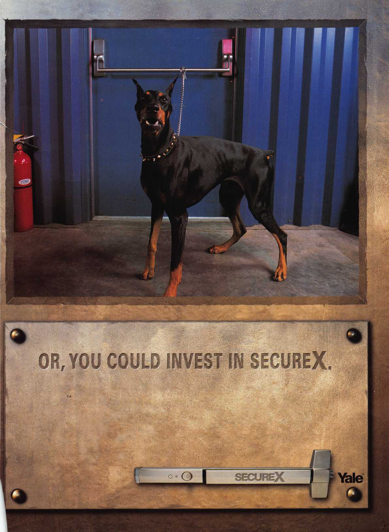

mmSM

pillJlil a tSfe^iS5! mmBSSBm

mil

**Hickok’s New Generation STAR transports you with the factory tool for programming keys to**

**Ford-Lincoln-Mercury and Mazda vehicles with passive anti theft systems (PATS).**

**Program vehicle keys through Model Year 2001 with Hickok’s NGS Model 800-8LA-$1995 ^ Update your existing software-the 2001 Complete New Model Ford Software Update Model 80LA-$895**

**800**/**342-5080**

**HICKOK**

INCORPORATED

**[www.hickok-inc](http://www.hickok-inc)**

